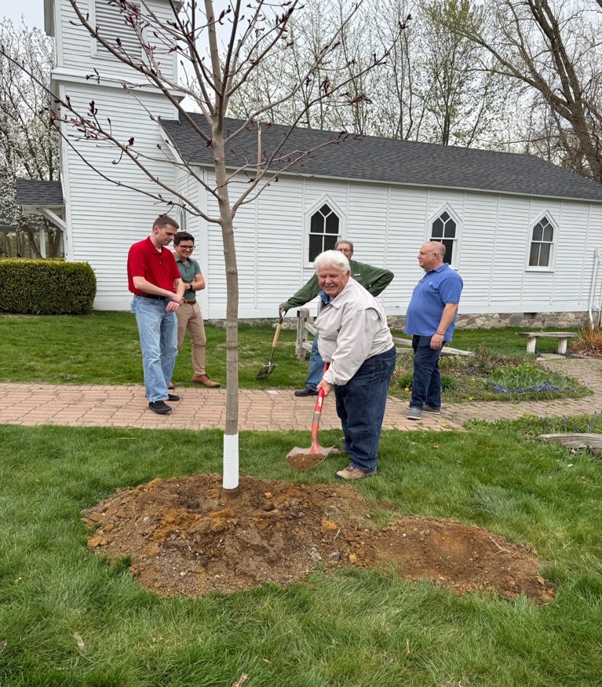
THE CITY OF SOUTH LYON DEPARTMENT OF PUBLIC WORKS
CORDIALLY INVITES YOU TO ATTEND THE

26TH ANNUAL ARBOR DAY CEREMONY

CELEBRATING THE CITY’S DESIGNATION AS A

TREE CITY USA COMMUNITY

ON

FRIDAY, APRIL 24, 2026, AT 4:30PM

AT

COLUMBIA PARK IN HUNTER’S CREEK SUBDIVISION
(From 10 Mile Road [West of Martindale Road] to Easton Drive heading South to the end,
then turn right on Columbia Drive. Columbia Park is on the right-hand side.)

THE CEREMONY WILL FEATURE A TREE PLANTING, AND MAYOR STEVE KENNEDY WILL DELIVER THE CITY’S OFFICIAL ARBOR DAY PROCLAMATION. THE SOUTH LYON AREA GIRL SCOUTS – JUNIORS TROOP 77575 - WILL ASSIST WITH PLANTING AND WATERING THE TREE. EACH TROOP MEMBER PARTICIPATING IN THE ACTIVITY WILL EARN THE “TREE PROMISE BADGE.”

TREES PROVIDE MANY VALUABLE BENEFITS TO OUR COMMUNITY, INCLUDING STORMWATER ABSORPTION AND FILTRATION, IMPROVED AIR QUALITY, SHADE, INCREASED PROPERTY VALUES, AND REDUCED SOIL EROSION – CONTRIBUTING TO A MORE SUSTAINABLE AND ATTRACTIVE ENVIRONMENT.

BROUGHT TO YOU BY THE CITY OF SOUTH LYON DEPARTMENT OF PUBLIC WORKS, WITH SUPPORT FROM THE STORMWATER MANAGEMENT PLANNING PROGRAM. (PICTURED ABOVE: MAYOR STEVE KENNEDY AT THE 25TH ANNUAL ARBOR DAY CEREMONY IN MCHATTIE PARK, SOUTH LYON, MI.)

PRESS RELEASE – FOR IMMEDIATE RELEASE (2 PAGES)

South Lyon Celebrates 26th Annual Arbor Day with Tree City USA Ceremony
  - Community Invited to Join Tree Planting and Recognition Event
The City of South Lyon Department of Public Works is pleased to announce the 26th Annual Arbor Day Ceremony, honoring South Lyon’s continued distinction as a Tree City USA community. The ceremony will take place on Friday, April 24, 2026, at 4:30 PM at Columbia Park in Hunter’s Creek subdivision, South Lyon, MI 48178.
Community members are invited to join Mayor Steve Kennedy, who will deliver the city’s official Arbor Day proclamation. The ceremony will feature a special tree planting, with South Lyon Area Girl Scouts – Juniors Troop 77575 – assisting in planting and watering the new tree. Troop members taking part in this activity will earn the “Tree Promise Badge,” highlighting their commitment to environmental stewardship.
Trees play a vital role in enhancing South Lyon’s quality of life. They absorb and filter stormwater, improve air quality, provide shade, increase property values, and reduce soil erosion—contributing to a more sustainable and attractive community.
This event is organized by the City of South Lyon Department of Public Works, with support from the Stormwater Management Planning Program. Last year, Mayor Kennedy led the 25th annual celebration at McHattie Park, demonstrating the city’s ongoing dedication to environmental initiatives and sustainability.
For directions: From 10 Mile Road (west of Martindale Road), head south on Easton Drive to the end, turn right on Columbia Drive, and Columbia Park will be on the right-hand side.
All residents and local organizations are encouraged to attend and participate in this meaningful community tradition.
Please call Suzann with any questions. 248-437-4942. Visit: southlyonmi.org, and/or arborday.org.

