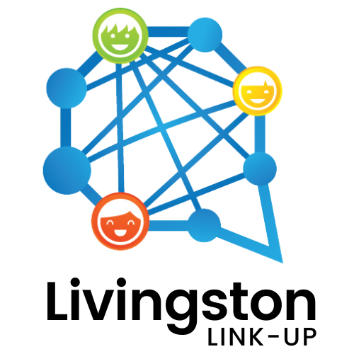 |  |  |  | Livingston Link-Up Invites Professionals To Come Meet Their Fellow Public Service Providers

For Immediate Release

January 18, 2023

HOWELL, Mich. – The Livingston Link-Up invites business professionals, medical personnel, care providers, and those who assist residents in need to their free event Friday, February 3rd from 4 – 6:30 p.m. at 2|42 Community Church in Brighton (7526 Grand River Ave.) This is the perfect opportunity for professionals and organizations to meet up with the people and groups working on local issues. Your referrals, insights, volunteerism, and financial support might be the missing link in solving some of our shared community challenges!

“This event provides an opportunity for Livingston County agencies and organizations to network and build relationships that will last beyond the event and lead to collaboration across sectors which further supports our residents in need,” said Amy Johnston, the Community Collaborative Planner for the Livingston County Human Services Collaborative Body.

Register here https://events.r20.constantcontact.com/register/eventReg?oeidk=a07ejhhqx8dd0227936&oseq=&c=&ch to save your spot for the event. The deadline to register is January 25th, so be sure to sign up today.

This networking event is sponsored by the Bank of Ann Arbor Livingston and The Livingston County United Way.
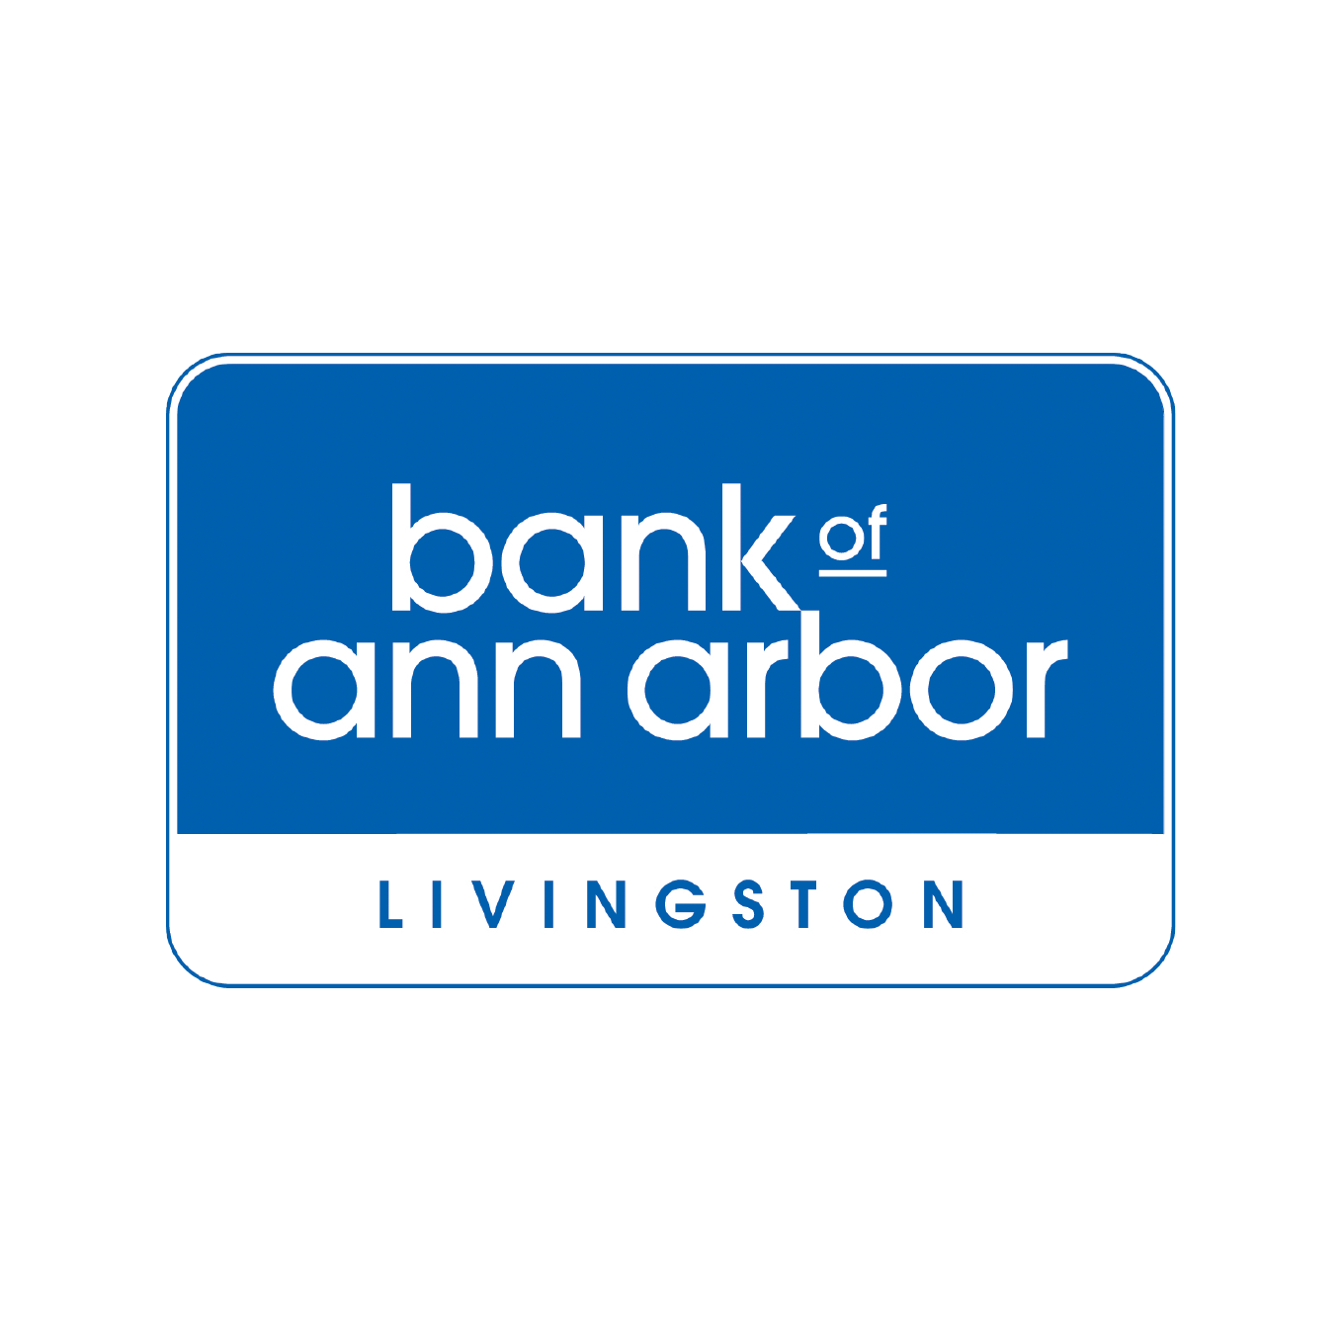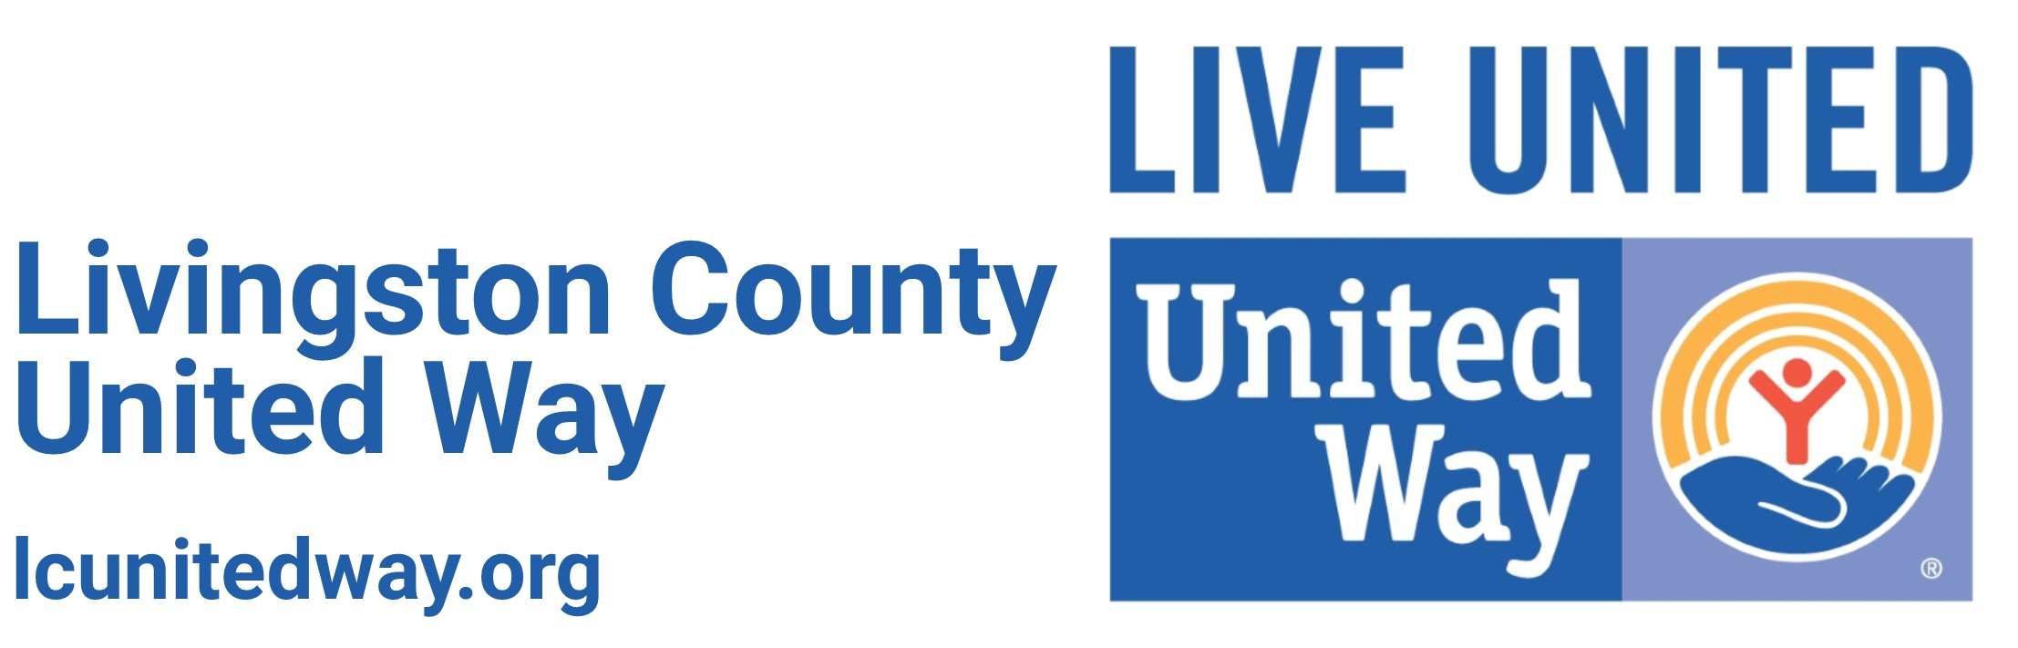
 |  | Friday, February 3rd
 |  | 4:00 – 6:30 p.m.
2|42 Community Church
7526 Grand River Ave, Brighton
 |  | Sponsored by Bank of Ann Arbor Livingston & Livingston County United Way

