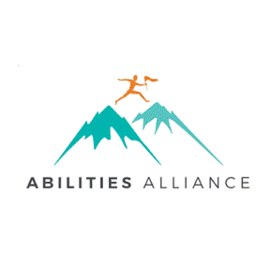
FOR IMMEDIATE RELEASE

Contact:
Amy Johnston, Community Collaborative Planner September 22, 2022
810.772.4827 | ajohnston@cmhliv.org

All Abilities Survey Results
A Look at Disability Needs In Livingston County

The Abilities Alliance announces the release of their report regarding the Disability Needs in Livingston County.

The Abilities Alliance is a workgroup of the Livingston Human Services Collaborative Body, a coalition of disability service organizations that strive to provide the most effective services for ALL ABILITIES in our community. The Abilities Alliance sends out a survey every other year to understand needs, identify service gaps and gather information from Livingston County community members who identify as having a disability. The survey was open to any Livingston County community member with a disability. Support persons, caregivers, parents, or providers were encouraged to help the individual(s) complete the survey.

Livingston County residents with disabilities were surveyed in early 2022 in order to gather data for this need’s assessment. “Difficulty finding in home and personal care assistants, not having adequate supports and resources to live independently and a lack of social and recreational activities were among the most reported unmet needs,” said Katie Oswald of Full Spectrum Agency for Autistic Adults and Chair of the workgroup. Information regarding utilization of local services and supports, barriers and additional unmet needs was also gathered.

The Abilities Alliance workgroup continues to raise awareness about inclusion and accessibility for people of all abilities in Livingston County. The needs survey is an important part of understanding what services people need most in our community. We will continue to learn from our community members and encourage others to take steps toward greater inclusion.

Please see the attached infographic for an overview of the results.

To learn more about the Abilities Alliance workgroup for the Livingston County Human Services Collaborative Body, visit: https://www.livgov.com/hscb/Pages/Abilities-Alliance.aspx
or check out https://www.facebook.com/livingstonabilitiesalliance. To obtain more information, contact Amy Johnston at 810.772.4827 or at ajohnston@cmhliv.org.

###

