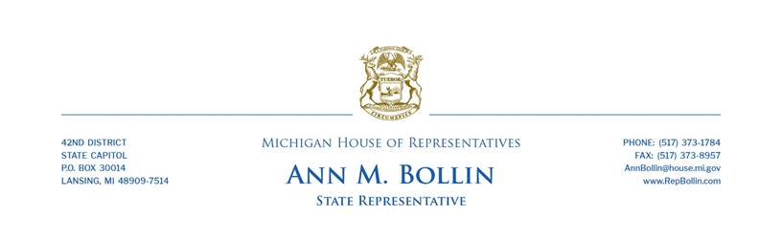

Rep. Bollin responds to governor’s State of the State address

State Rep. Ann Bollin today released the following statement in response to the governor’s State of the State address:
“The small businesses that put people to work and help our communities thrive have been put through the wringer over the past two years. The governor’s economic shutdown and the staffing and supply chain shortages created by the pandemic have been incredibly tough on everyone, especially our job providers. I’ve been working hard with my legislative colleagues to do everything we can to offer relief and keep their doors open.
“Despite resistance from the governor’s office, House Republicans have successfully fought to get relief for small businesses signed into law. These efforts are something to be proud of, and I’m glad the governor finally sees enough merit to tout them during her State of the State address.
“Just this morning, I voted to advance a $184.6 million plan to help small businesses hurt by the pandemic that have been left out of other programs. Now that the governor has taken a public victory lap for our ideas, I expect that we should have no problem getting this signed into law.”
###

