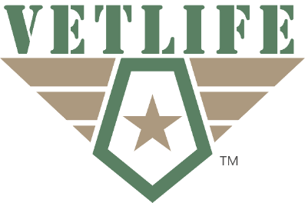

FOR IMMEDIATE RELEASE Contact: Joshua Parish, President of VETLIFE
JULY 2, 2021, josh@vetlifetoday.org | 906.430.1679

Vet Fest presented by VETLIFE: Michigan’s Largest Veteran Event of the Year

Howell, Michigan – Michigan veteran nonprofit VETLIFE brings the veteran community the largest FREE veteran event in the State of Michigan. This is the third year for the event in Michigan and it has substantially grown every year. The purpose of Vet Fest is to bring veterans across the state together to enjoy camaraderie and connect them to their military benefits they earned through their service to this county.

VETLIFE President Joshua Parish says, “Michigan is home to almost 600,000 veterans, but in 2019 less than 12% of Michigan veterans were connected to a federal benefit. VETLIFE is doing something no other organizations have successfully been able to do and that is connect veterans to their benefits at a very large scale.” Joseph Riker of VETLIFE commented, “VETLIFE works very closely with our local County Department of Veteran Affairs office, and we found that the month after our last Vet Fest event the office saw a 60% increase in veterans searching out their benefits.”

VETLIFE covers all costs of Vet Fest so the entire event is free for veterans and additionally, all of the resources at the event are veteran specific. The event is family orientated and veteran’s family members can enjoy food, bounce houses, live music, backpack, and school supply giveaways, and more. All veterans in attendance are also eligible to win a wide variety of prizes valued from $300 - $1,500. Vet Fest is open to all active duty, retired, or military veteran families from anywhere in the country. Registration is required for entry and veterans will be asked to show a military ID at check in to verify service (Department of Defense Identification Card, VA Health Identification Card, or veteran designation on a state issued driver’s license will all be acceptable forms of verification).
VETFEST WILL FEATURE:
• Live Bands: Dually Noted and Billy Gunther & The Midwest Riders
• Kids Zone (featuring bounce houses and other kid activities)
• Backpack and school supply giveaways to the first 300 school aged veteran children
• Military, EMS, Fire, and Police vehicles on display
• Celebrity appearances
• Multiple food trucks providing complimentary food and beverages
• Prizes valued up to $1,500 (awarded to active duty and veterans in attendance)
• Over 60 veteran specific resource providers on site to help answer questions regarding benefits

For more information on Vet Fest and to register please visit: bit.ly/vetfest2021
To learn more about VETLIFE or to make a tax-deductible donation visit: www.vetlifetoday.org
Questions? Email Joshua Parish at josh@vetlifetoday.org
VETLIFE’s Mission: To provide veterans with sustainable solutions while promoting a safer, healthier, and prosperous civilian lifestyle.

