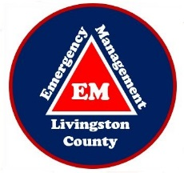

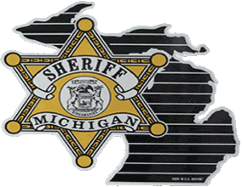
Livingston County 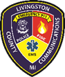

Emergency Management

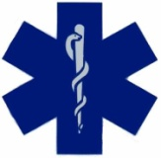
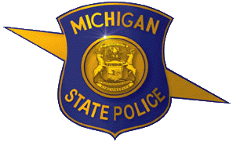
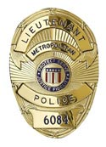
1911 Tooley Road
Howell, Michigan 48855
Telephone 517.546.6220

Fax 517.546.6788

Director: Jeffrey R. Boyd Emergency Manager: Therese Cremonte

PRESS RELEASE: September 15, 2017

The Livingston County Public Alerting System and the Smart 911 System are two important public safety tools, but both serve different, but relevant purposes.

The difference between the systems:
Public Alerting – when we need to contact the citizens and warn them of imminent danger
911 Systems – when the public needs to contact us to ask for help in an emergency

Having both systems in place allows a back and forth information flow prior to and during emergencies or disasters.

The alerting system is utilized when responders need to warn the public of instances of imminent life safety, such as a tornado, a hazardous materials spill, or other instance that put the public in great peril. The system also allows the citizens to opt in and choose less life threatening events to be notified about, such as ice storms, severe thunder storms, possible flooding, and others. The only warning they cannot opt out of is a tornado warning. That warning will come directly from the National Weather Service to the Public Alerting System because we believe tornados to be our most dangerous natural hazard.

Other warnings that come through the system would be vetted and approved by the Emergency Management Department. This is because we do not want the Public Alerting System to be overused. The public could quickly become desensitized to the alerts, which would undermine the purpose in the event of a true emergency.

Our Public Alerting System is also a platform for IPAWS (Integrated Public Alert & Warning System) The IPAWS system would be utilized on the national level if we were to ever experience a national event that could have implications locally. The best example of that would be the 9/11 attacks. The President of the United States would be able to send a message out via IPAWS to our citizens.

When people subscribe their cell phones, they can be alerted in different manners and in the order they choose to be alerted. They can also enter up to five different numbers to be contacted – so if you have a relative that is out of the area that is an emergency contact for you – you may put their cell number in your profile, so if you are being alerted, they are made aware of the alert also.

This system came into being January of 2017. Prior to that time, Livingston County did not have a public alerting system to contact our citizens. This is an advance in our local technology to help keep the citizens of Livingston County safer and better informed. However, if we can’t find you, we can’t alert you. Please take the time to sign up and spread the word to those you care about.

If you have any additional questions, please feel free to contact Livingston County Emergency Manager, Therese Cremonte at 517-540-7926.

