8/3/26 WHMI.com submission for August 8 Event

The Brighton Area Women’s History Roll of Honor and the Brighton District Library invite all friends, families, and community members to join us in celebrating the Class of 2026 Honorees on Saturday, August 8th, at 2pm in the Main Reading Room. The free program highlights the accomplishments of these amazing women and their contributions to the community.

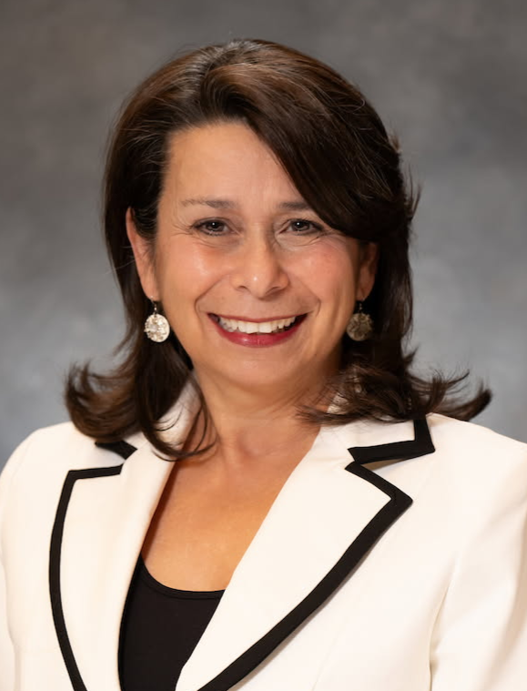
Kathy Aksten is a 1977 Brighton High School graduate, began her career in the financial services industry, and was named by Forbes as a 2024 Top Women Advisor in America. Kathy is also co-owner of the Triple Diamonds Alpaca Ranch, home to one of the largest seed stock breeding farms with 100-150 alpacas and an on-site alpaca boutique.

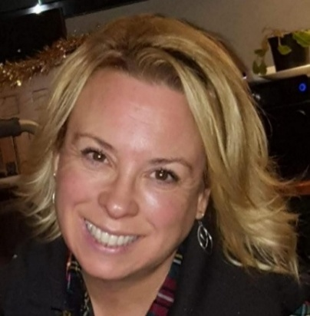
Renée Pettengill has served on Brighton’s City Council since 2016. Renée initiated efforts in 2011 to restore Brighton’s Imagination Station and has led annual cleanup, repair, and beautification. She holds two leadership positions with Boy Scout Troop 350 and coaches the Scranton Middle School tennis team. Renée is currently Chief of Staff for the President of Cornerstone Schools.

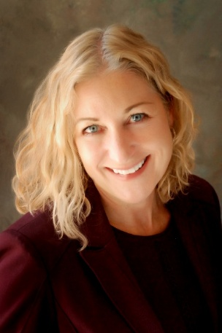
Catherine Riesterer founded the law firm Cooper & Riesterer, PLC, in 2000 while serving as Managing Partner through 2025. Cathy is a Past President of the Brighton Rotary Club, where she also served as Chair of the Scholarship Committee, the Youth Exchange Committee, and hosted three foreign exchange students. Cathy is a past board member and legal advisor of VINA Community Dental Center (2010-2021) and has served as an Adjunct Professor (2003-2005) and Board of Directors Member for Cleary University (2020-2024).


Kari Seitz graduated from Brighton High School in 1988 and was appointed Head of Refereeing for FIFA from 2016-2024. Her tenure was defined by sustained efforts to break long-standing gender barriers in international refereeing. Kari has served as Vice President of Refereeing, U.S. Soccer Federation since 2024.

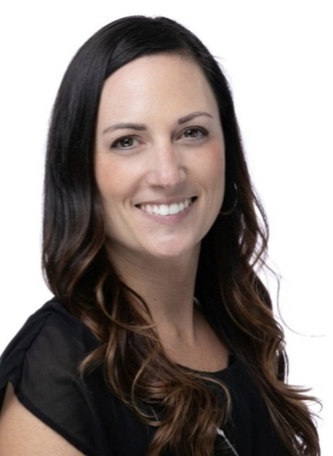
Ashley Watterson is a 2002 graduate from Brighton High School and founded Tocca Massage Therapy in 2011. She founded the nonprofit Yoga Strong Foundation and the Bend & Brew program has awarded $46,000 in scholarships and collected food donations that helped establish a food pantry at FlexTech High School. She has led Operation Christmas Wishes since 2018 in partnership with leadership classes at Brighton and Pinckney High Schools.
Outstanding Historical Accomplishments by a Women’s Organization

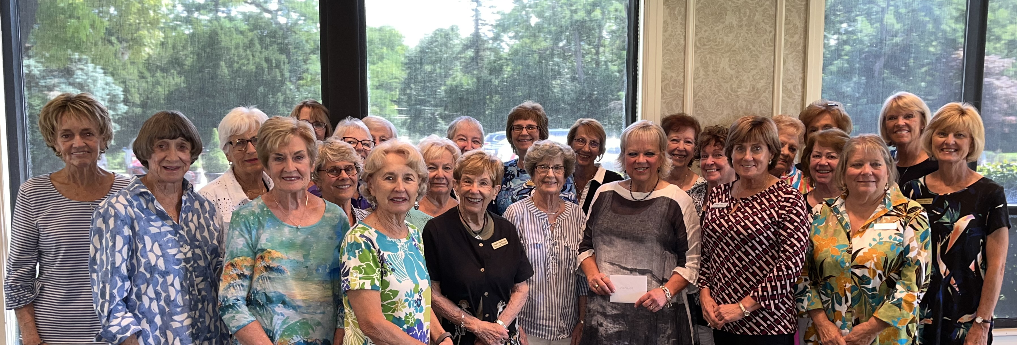

The Livingston Women’s Club (LWC) was founded in 1987 to help disadvantaged individuals and families in Livingston County. Their Giving Tree Project provided 1,145 gifts in 2024. The LWC offers college scholarships, supports The Connection Youth Center with monthly donations, and offers a crisis fund to aid individuals and families with emergencies. LWC supports LACASA, the “Brighton Blessings in a Backpack” program, Pregnancy Help Clinic, The Ivy Table, VINA Dental, Meals on Wheels, and many other endeavors through volunteer hours and funding.

Outstanding Historical Accomplishments by Young Women

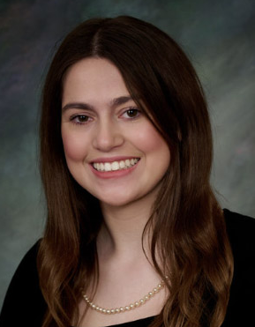
Ari Hickman, the 2026 Brighton High School valedictorian, has been a freelance writer for The Livingston Daily Press & Argus since 2023, publishing over 40 articles, with several being republished with The Detroit Free Press and The Lansing State Journal. Ari was selected as the 2025 Michigan representative to the “Al Neuharth (founder of USA Today) Free Spirit and Journalism Conference” in Washington, DC, receiving a $1000 college scholarship and an all-expenses-paid trip to the conference.

Hannah Palmer, a 2018 Brighton High School graduate, was crowned Miss Michigan 2026 during the 86th annual scholarship competition. A third-grade teacher in Ann Arbor, she is the founder of The Sunflower Project, a nonprofit dedicated to providing social-emotional learning (SEL) resources to students and families.


Jillian Weaver, a 2026 Brighton High School graduate, was chosen as a flag football running back representing the Detroit Lions in the 2026 NFL Pro Bowl Flag Football Showcase with 31 other girls, each representing a NFL team across the country. Jillian’s BHS team competed in the 2025 inaugural state championship game at Ford Field.

