  - Press Release - For Immediate Release

22nd Annual South Lyon Area Creek Cleanup and Earth Day Event

South Lyon Community Invited to 22nd Annual Creek Cleanup and Earth Day Event
South Lyon, MI – The South Lyon Area community is invited to join the 22nd Annual South Lyon Area Creek Cleanup and Earth Day Event, dedicated to conserving and protecting our local waterways. This longstanding event encourages both young people and adults to take part in a meaningful morning of service which will make a direct impact on the health and beauty of our creeks, streams, and waterways.

Event Details
- Date: Sunday, April 19, 2026
- Time: 9:00 AM – 1:00 PM (complimentary lunch served at noon at the South Lyon VFW Hall, 125 E McHattie St)
- Meeting Place: Michigan Seamless Tube and Pipe Company – Truck Parking Lot, 400 McMunn St, South Lyon

Purpose and Call to Action
Volunteers will safely remove trash and debris from South Lyon area creeks, streams, and waterways. This vital community service protects our environment, enhances public spaces, keeps green infrastructure such as storm drains flowing, and fosters local stewardship. All residents are encouraged to take part and help make a visible difference.

Volunteer Instructions
- It may be cold, and water levels will be high – please plan accordingly.
- Strongly encouraged attire: Rubber boots (optional), gloves, a bright long sleeve shirt, and long pants. Safety vests will be provided.
- Also Needed (optional): Rakes, shovels, trucks, and trailers for hauling event trash to the dumpster.
For safety, all participants are reminded to dress appropriately and bring tools if available. Please note that dumpster is for event trash only.

Sponsor Recognition
This event is made possible thanks to generous support from:
- South Lyon Area Boy Scouts Troop 228 (Founding Members)
- South Lyon Area Cub Scouts Pack 38
- City of South Lyon Department of Public Works – Storm Water Management Planning Program
- City of South Lyon Water Department – Wellhead Protection Program
- Michigan Seamless Tube and Pipe Company
- South Lyon Veterans of Foreign Wars Post 1224
- Larry and Delynn Ledbetter
- South Lyon Water Guardians
- Martin’s Hardware
- Vibe Credit Union
- Matt and Lisa Brumm
- South Lyon Area Democrats
- Steve and Lori Mosier
- South Lyon Area Republicans
The City of South Lyon and event organizers extend heartfelt thanks to all sponsors for their commitment to environmental stewardship and community service.

Closing Statement
The South Lyon Area Creek Cleanup and Earth Day Event is a wonderful opportunity to give back, connect with neighbors, and protect our natural resources. All are welcome—bring your friends and family for a day of teamwork and celebration. For questions or further information, please contact the event organizers at 248-437-4942, or visit the City of South Lyon website at southlyonmi.org. Join us and make a lasting difference for our waterways and our community.

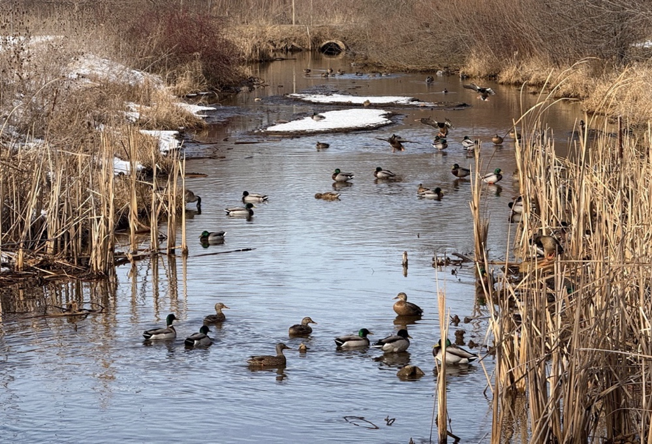
YOU ARE INVITED TO:
CONSERVE & PROTECT OUR WATERWAYS
“COMMUNITY SERVICE FOR YOUNG AND YOUNG AT HEART”
“22nd ANNUAL SOUTH LYON AREA
CREEK CLEANUP AND EARTH DAY EVENT”
(SAFELY REMOVING TRASH AND DEBRIS FROM SOUTH LYON AREA CREEKS, STREAMS, AND WATERWAYS)
DATE: SUNDAY, APRIL 19, 2026, TIME: 9AM – 1PM (complimentary lunch at noon at the VFW Hall at 125 E McHattie St)
MEETING PLACE: 400 MCMUNN ST – MICHIGAN SEAMLESS TUBE AND PIPE COMPANY - TRUCK PARKING LOT, SOUTH LYON
“It may be cold, and the water will be high.”
IT IS STRONGLY ENCOURAGED TO WEAR: rubber boots, gloves, bright long sleeve shirt, and long pants. Safety vests provided.
ALSO NEEDED (not required): rakes, shovels, trucks, and trailers to haul trash to dumpster. For event trash only.
THANK YOU TO OUR SPONSORS!:
-SOUTH LYON AREA BOY SCOUTS TROOP 228 (FOUNDING MEMBERS), AND SOUTH LYON AREA CUB SCOUTS PACK 38
-CITY OF SOUTH LYON DEPARTMENT OF PUBLIC WORKS - STORM WATER MANAGEMENT PLANNING PROGRAM
-CITY OF SOUTH LYON WATER DEPARTMENT - WELLHEAD PROTECTION PROGRAM
-MICHIGAN SEAMLESS TUBE AND PIPE COMPANY
-SOUTH LYON VETERANS OF FOREIGN WARS POST 1224
-LARRY AND DELYNN LEDBETTER
-SOUTH LYON WATER GUARDIANS
-MARTIN’S HARDWARE
-VIBE CREDIT UNION
-MATT AND LISA BRUMM
-SOUTH LYON AREA DEMOCRATS
-STEVE AND LORI MOSIER
-SOUTH LYON AREA REPUBLICANS

