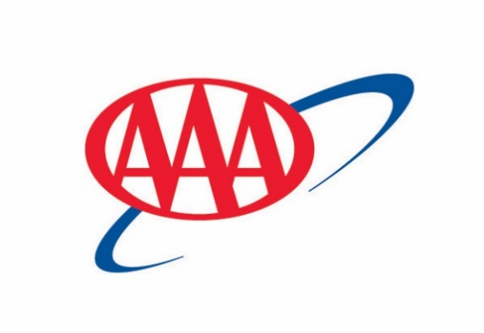 | NEWS RELEASE
AAA Helps Travelers Navigate Spring Break Plans as Fuel Prices and International Headlines Evolve
AAA survey: 1-in-4 Michiganders will take a spring break vacation
DEARBORN, Mich.,) — AAA’s latest survey of Michigan residents finds strong travel intent for 2026, with Michiganders planning more vacations this year than last. One in four Michigan residents (26%) reported plans to travel for spring break.
Spring breakers are willing to travel:
- 79 percent to another state
- 13 percent within the state
- 8 percent internationally
*The survey was completed in early February
Popular Spring Break Destinations
Based on AAA travel bookings
Domestic  - Orlando  - Fort Lauderdale  - Miami  - Anaheim/LA  - Tampa  - Honolulu  - Las Vegas  - New York  - Atlanta  - Chicago | International  - Rome, Italy  - Paris, France  - Cancun, Mexico  - Amsterdam, Netherlands  - London, England  - Barcelona, Spain  - Punta Cana, Dominican Republic  - San Juan, Puerto Rico  - Oranjestad, Aruba  - Dublin, Ireland

“Even with headlines about gas prices and international events, most vacations will continue smoothly," said Debbie Haas, Vice President of Travel for AAA – The Auto Club Group. “Preparation, flexibility, and protection give travelers peace of mind, and AAA can help with all three.”
Spring Break Road Trips: What to Know
Gas prices are rising as many families head out for spring break road trips. Michigan’s average price rose 62 cents over the past nine days, roughly $10 more for a full tank of gas. Visit GasPrices.AAA.com to review daily gas price averages.
“The recent gas price hike comes after most people had already finalized their spring break travel plans, so it is unlikely that they will cancel their trips,” said Adrienne Woodland, spokesperson for AAA. “What we typically see is that travelers rebalance their budgets. Many choose to spend a little less on dining out or shopping so they can keep their itinerary intact.”
How to trim road trip costs without cutting the trip
- Compare fuel prices using the AAA app or in-vehicle navigation tool.
- Use AAA’s Gas Cost Calculator to estimate fuel expenses for your road trip and plan your budget accordingly.
- Use AAA member discounts on hotels, rental cars, attractions, and dining.
- Check tire pressure and remove excess weight to improve fuel economy.
- Pack snacks and reusable water bottles to reduce food costs.
- Book refundable rates so you can adjust plans if prices change.
For Air Travelers: Navigating A Partial Government Shutdown
Air travel continues, but a partial government shutdown can create pressure points across the system. Travelers may encounter longer lines at security, fewer nonessential services, and occasional schedule adjustments while agencies manage staffing and priorities.
“Most flights are operating on time, and major airports remain open,” said Haas. “Give yourself extra time, build in buffers, and lean on tools that reduce friction.”
Tips to reduce stress at the airport
- Book the first flight of the day, which is statistically less prone to rolling delays.
- Aim for nonstop flights when possible or allow longer connection times.
- Arrive earlier than usual, especially during peak morning and late afternoon windows.
- Enroll in TSA PreCheck to speed security screening.
- Monitor your flight in the airline app and enable push alerts.
- Avoid tight checked-bag connections by using carry-on only, if practical.
- Consider travel insurance that includes trip interruption and delay benefits.
International Outlook: Mexico
Many Michiganders plan to visit Mexico’s resort areas during spring break and beyond. Geopolitical tensions can evolve, which is why AAA advises travelers to stay informed and follow common-sense safety practices.
What travelers should know and how to stay safe
- Check the U.S. Department of State’s website for any travel advisories that might affect your destination.
- Register your trip with the Smart Traveler Enrollment Program (STEP), to receive safety updates.
- Stay within well-known resort zones and booked tour corridors, particularly after dark.
- Use hotel-arranged or vetted transportation and avoid hailing rides on the street.
- Keep a low profile, secure valuables, and use in-room safes.
- Confirm your passport has at least six months of validity beyond your return date.
“Mexico remains a top destination for many of our members,” said Haas. “Choosing reputable resorts, using verified transportation, and staying informed can make every trip safer and more enjoyable. AAA travel agents can help travelers evaluate their options and make informed decisions about where to stay, how to get around, and what to expect when they arrive.”
Regional Considerations: Iran Conflict and Nearby Airspace
Despite the Iran conflict, popular international destinations like Rome, Paris, and Barcelona are still accessible. However, developments related to the conflict can affect flight routings and regional operations. Airlines may adjust flight paths or schedules in response to airspace notices and evolving conditions. Travelers with itineraries that touch the broader region should stay closely connected with their airline and travel advisor.
Safe travel guidance
- Monitor airline emails and app notifications for any reroutes or time changes.
- Review government travel advisories for your specific destinations and any planned connections.
- Avoid border areas, protest sites, and large public gatherings.
- Keep copies of travel documents in a separate location and share your itinerary with family.
- Consider flexible booking options and comprehensive travel insurance, including Cancel For Any Reason and trip interruption. Acts of war are generally excluded from most travel insurance policies. AAA encourages travelers to work with a trusted travel agent who can walk you through the policy details and answer questions about what is and isn’t included in case of an emergency.
“Travel conditions can change quickly, which is why it helps to have support when planning a trip,” said Haas. “If your itinerary includes areas experiencing disruptions or uncertainty, AAA travel agents can help you design a trip that aligns with your comfort level, preferences, and expectations from the very beginning.”

