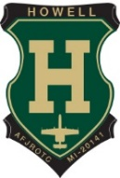 **10th Annual Howell Air Force** 

**JROTC Golf Outing**



**September 21** 8am Registration Sunday 2025 9am Shotgun start

Willow Brook *Golf Club* *Breakfast, Lunch & Byron MI Dinner provided*

**Prizes**

**Raffle**

**50/50**

**All Ages Welcome!!**

All Proceeds Go To

Howell AFJROTC Program

***Please visit*** [***www.howellafjrotc.com***](http://www.howellafjrotc.com)

***For more Information***