**FOR IMMEDIATE RELEASE**

**Statistics Contact:** Francine L. Green, Realcomp [248-553-3003, ext. 114], fgreen@corp.realcomp.com

**Sales Increase for 2nd Straight Month,**

**Inventory is at 5-Year MLS High for July**

**Realcomp Y-O-Y Quick Facts for July 2025**

|  |  |  |  |  |  |
| --- | --- | --- | --- | --- | --- |
| **Closed Sales** | **Pending Sales** | **Median Sale Price** | **New Listings** | **Homes On Market** | **Avg. Days on Market** |
|  |  |  |  |  |  |
| **10,507** | **9,778** | **$297,500** | **15,404** | **25,062** | **31** |
| **Up by .6%** | **Down by 3.7%** | **Up by 7%** | **Up by 5.7%** | **Up by 20.5%** | **Up by 2 days** |

**National Real Estate Commentary**

U.S. existing-home sales fell 2.7% from the previous month to a seasonally + adjusted annual rate of 3.93 million, according to the National Association of REALTORS® (NAR). Sales were unchanged from one year earlier. Regionally, monthly sales declined in the Midwest, Northeast, and South but rose in the West. Year-over-year, sales decreased in the Northeast and West but increased in the South and Midwest.

Nationally, the median existing-home sales price rose 2.0% year-over-year to $435,300, a new monthly high and the 24th consecutive month of annual price gains, according to NAR. Slower sales activity has contributed to rising inventory this year, with 1.53 million properties listed for sale heading into

July, a 15.9% increase from the same time last year and equivalent to a 4.7-month supply at the current sales pace.

**July – Local Activity**

Closed Sales increased 1.4 percent for Residential homes but decreased 5.5 percent for Condo homes. Pending Sales decreased 3.7 percent for Residential homes and 4.1 percent for Condo homes. Inventory increased 20.5 percent for Residential homes and 20.2 percent for Condo homes.

The Median Sales Price increased 7.1 percent to $300,000 for Residential homes and 2.7 percent to $275,000 for Condo homes. Days on Market increased 6.9 percent for Residential homes and 16.1 percent for Condo homes. Months-Supply of Inventory increased 21.7 percent for Residential

homes and 20.0 percent for Condo homes.

***“An increase in sales is a positive at any level, especially when we are experiencing it two-months in-a-row,” said Karen S. Kage, Realcomp CEO. “At the same time, inventory levels and median sales prices remain strong.”***

**July Comparisons – Res & Condo Combined - All MLS**

* New Listings increased by 5.7% from 14,572 to 15,404 Year-Over-Year (YOY). New Listings increased from 15,245 Month-Over-Month (MOM), an increase of about 1.04%.
* Pending Sales decreased by 3.7% from 10,157 to 9,778 YOY. Pending Sales decreased from 10,352 MOM, a decrease of approximately 5.54%.
* Closed Sales increased slightly by .6% from 10,448 to 10,507 YOY. Closed Sales increased from 10,352 MOM, an increase of approximately 1.5%.
* Average Days on Market (DOM) increased by 2 days from 29 to 31 YOY. Average Days on Market stayed the same MOM.
* Median Sale Price increased by 7.0% from $278,000 to $297,500 YOY. Median Sale Price increased from $295,000 MOM, an increase of .85%.
* Percentage of Last List Price Received decreased slightly by .5% from 99.9% to 99.4% YOY. Percentage of Last List Price Received decreased from 99.7% MOM, a difference of .3%.
* Inventory of Homes for Sale increased by 20.5% from 20,805 to 25,062 YOY. Inventory of Homes for Sale increased from 23,280 MOM, an increase of 7.65%.
* Month’s Supply of Inventory increased by 16.7% from 2.4 to 2.8 YOY. Month’s Supply of Inventory increased from 2.6 MOM, an increase of .2 months.
* Average Showings per Home decreased from 8.4 to 5.7 YOY. Average Showings decreased from 5.9 MOM, a difference of .2 showings.
* Listings that were both listed and pended in the same month were at 4,328. This represents 28.1% of the new listings for the month and 44.3% of the pended listings. Listings that were both listed and pended in the same month decreased from 4,884 MOM.

**~~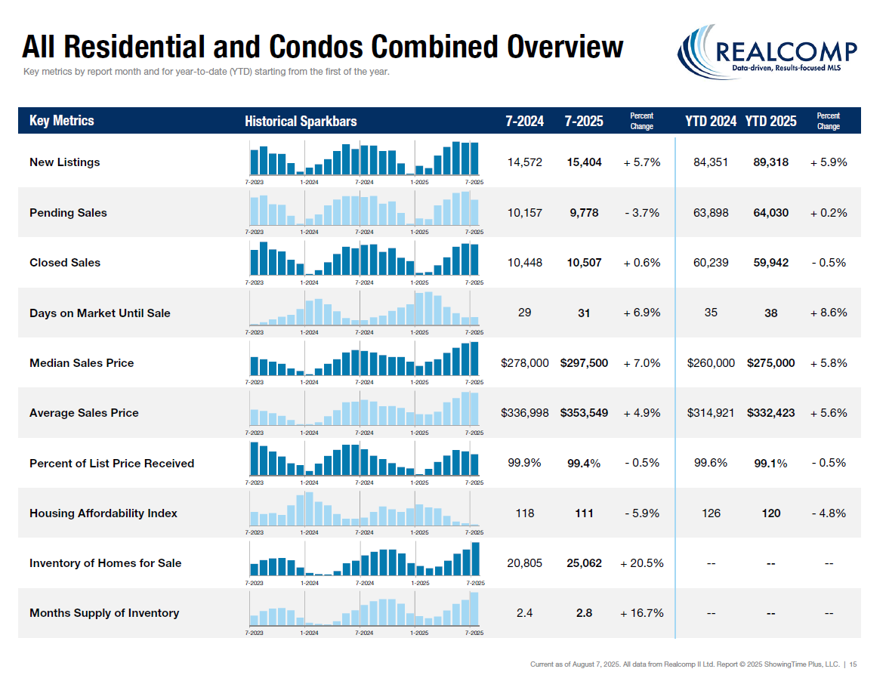~~**

**July 5-Year Perspectives – Res & Condo Combined – All MLS**

|  |  |  |  |  |  |  |  |
| --- | --- | --- | --- | --- | --- | --- | --- |
| **Closed Sales** | | **Pending Sales** | | **Median Sale Prices** | | **Overall Inventory** | |
| Date | Count | Date | Count | Date | Price | Date | Count |
| July-21 | 13,272 | July-21 | 13,022 | July-21 | $238,263 | July-21 | 21,132 |
| July-22 | 11,920 | July-22 | 11,634 | July-22 | $255,000 | July-22 | 23,921 |
| July-23 | 9,684 | July-23 | 10,114 | July-23 | $265,000 | July-23 | 18,089 |
| July-24 | 10,448 | July-24 | 10,157 | July-24 | $278,000 | July-24 | 20,805 |
| July-25 | 10,507 | July-25 | 9,778 | July-25 | $297,500 | July-25 | 25,062 |

**July 5-Year Perspectives – Res & Condo Combined – City of Detroit**

|  |  |  |  |  |  |  |  |
| --- | --- | --- | --- | --- | --- | --- | --- |
| **Closed Sales** | | **Pending Sales** | | **Median Sale Prices** | | **Overall Inventory** | |
| Date | Count | Date | Count | Date | Price | Date | Count |
| July-21 | 386 | July-21 | 425 | July-21 | $70,000 | July-21 | 1,523 |
| July-22 | 384 | July-22 | 331 | July-22 | $100,000 | July-22 | 2,364 |
| July-23 | 474 | July-23 | 535 | July-23 | $90,000 | July-23 | 2,361 |
| July-24 | 453 | July-24 | 464 | July-24 | $94,900 | July-24 | 2,432 |
| July-25 | 408 | July-25 | 465 | July-25 | $108,000 | July-25 | 2,551 |

**July 5-Year Perspectives – Res & Condo Combined – Genessee County**

|  |  |  |  |  |  |  |  |
| --- | --- | --- | --- | --- | --- | --- | --- |
| **Closed Sales** | | **Pending Sales** | | **Median Sale Prices** | | **Overall Inventory** | |
| Date | Count | Date | Count | Date | Price | Date | Count |
| July-21 | 556 | July-21 | 538 | July-21 | $187,750 | July-21 | 903 |
| July-22 | 475 | July-22 | 472 | July-22 | $200,000 | July-22 | 1,168 |
| July-23 | 419 | July-23 | 402 | July-23 | $200,000 | July-23 | 823 |
| July-24 | 476 | July-24 | 453 | July-24 | $200,000 | July-24 | 1,018 |
| July-25 | 459 | July-25 | 489 | July-25 | $224,000 | July-25 | 1,134 |

**July 5-Year Perspectives — Res & Condo Combined — Lapeer County**

|  |  |  |  |  |  |  |  |
| --- | --- | --- | --- | --- | --- | --- | --- |
| **Closed Sales** | | **Pending Sales** | | **Median Sale Prices** | | **Overall Inventory** | |
| Date | Count | Date | Count | Date | Price | Date | Count |
| July-21 | 98 | July-21 | 117 | July-21 | $275,000 | July-21 | 245 |
| July-22 | 108 | July-22 | 109 | July-22 | $275,500 | July-22 | 287 |
| July-23 | 83 | July-23 | 72 | July-23 | $291,000 | July-23 | 183 |
| July-24 | 80 | July-24 | 85 | July-24 | $291,250 | July-24 | 243 |
| July-25 | 102 | July-25 | 94 | July-25 | $305,000 | July-25 | 284 |

**July 5-Year Perspectives — Res & Condo Combined — Livingston County**

|  |  |  |  |  |  |  |  |
| --- | --- | --- | --- | --- | --- | --- | --- |
| **Closed Sales** | | **Pending Sales** | | **Median Sale Prices** | | **Overall Inventory** | |
| Date | Count | Date | Count | Date | Price | Date | Count |
| July-21 | 346 | July-21 | 315 | July-21 | $349,250 | July-21 | 520 |
| July-22 | 289 | July-22 | 268 | July-22 | $352,500 | July-22 | 582 |
| July-23 | 258 | July-23 | 233 | July-23 | $376,500 | July-23 | 398 |
| July-24 | 225 | July-24 | 238 | July-24 | $405,000 | July-24 | 447 |
| July-25 | 265 | July-25 | 209 | July-25 | $425,000 | July-25 | 537 |

**July 5-Year Perspectives — Res & Condo Combined — Macomb County**

|  |  |  |  |  |  |  |  |
| --- | --- | --- | --- | --- | --- | --- | --- |
| **Closed Sales** | | **Pending Sales** | | **Median Sale Prices** | | **Overall Inventory** | |
| Date | Count | Date | Count | Date | Price | Date | Count |
| July-21 | 1,394 | July-21 | 1,320 | July-21 | $229,450 | July-21 | 1,761 |
| July-22 | 1,169 | July-22 | 1,207 | July-22 | $245,000 | July-22 | 2,135 |
| July-23 | 952 | July-23 | 1,005 | July-23 | $248,500 | July-23 | 1,409 |
| July-24 | 1,076 | July-24 | 961 | July-24 | $265,000 | July-24 | 1,670 |
| July-25 | 985 | July-25 | 1,016 | July-25 | $280,000 | July-25 | 2,056 |

**July 5-Year Perspectives -- Res & Condo Combined -- Oakland County**

|  |  |  |  |  |  |  |  |
| --- | --- | --- | --- | --- | --- | --- | --- |
| **Closed Sales** | | **Pending Sales** | | **Median Sale Prices** | | **Overall Inventory** | |
| Date | Count | Date | Count | Date | Price | Date | Count |
| July-21 | 2,073 | July-21 | 1,970 | July-21 | $320,000 | July-21 | 3,295 |
| July-22 | 1,748 | July-22 | 1,721 | July-22 | $345,000 | July-22 | 3,485 |
| July-23 | 1,390 | July-23 | 1,467 | July-23 | $348,450 | July-23 | 2,327 |
| July-24 | 1,543 | July-24 | 1,443 | July-24 | $366,000 | July-24 | 2,567 |
| July-25 | 1,591 | July-25 | 1,535 | July-25 | $387,500 | July-25 | 3,176 |

**July 5-Year Perspectives -- Res & Condo Combined – St. Clair County**

|  |  |  |  |  |  |  |  |
| --- | --- | --- | --- | --- | --- | --- | --- |
| **Closed Sales** | | **Pending Sales** | | **Median Sale Prices** | | **Overall Inventory** | |
| Date | Count | Date | Count | Date | Price | Date | Count |
| July-21 | 207 | July-21 | 213 | July-21 | $219,000 | July-21 | 398 |
| July-22 | 208 | July-22 | 177 | July-22 | $225,000 | July-22 | 448 |
| July-23 | 198 | July-23 | 188 | July-23 | $209,950 | July-23 | 368 |
| July-24 | 176 | July-24 | 176 | July-24 | $250,000 | July-24 | 328 |
| July-25 | 205 | July-25 | 190 | July-25 | $264,900 | July-25 | 409 |

**July 5-Year Perspectives -- Res & Condo Combined -- Washtenaw County**

|  |  |  |  |  |  |  |  |
| --- | --- | --- | --- | --- | --- | --- | --- |
| **Closed Sales** | | **Pending Sales** | | **Median Sale Prices** | | **Overall Inventory** | |
| Date | Count | Date | Count | Date | Price | Date | Count |
| July-21 | 518 | July-21 | 481 | July-21 | $350,000 | July-21 | 1,307 |
| July-22 | 477 | July-22 | 439 | July-22 | $390,000 | July-22 | 1,157 |
| July-23 | 366 | July-23 | 356 | July-23 | $400,500 | July-23 | 874 |
| July-24 | 375 | July-24 | 355 | July-24 | $437,000 | July-24 | 659 |
| July-25 | 363 | July-25 | 242 | July-25 | $440,000 | July-25 | 918 |

**July 5-Year Perspectives -- Res & Condo Combined -- Wayne County**

|  |  |  |  |  |  |  |  |
| --- | --- | --- | --- | --- | --- | --- | --- |
| **Closed Sales** | | **Pending Sales** | | **Median Sale Prices** | | **Overall Inventory** | |
| Date | Count | Date | Count | Date | Price | Date | Count |
| July-21 | 1,942 | July-21 | 2,054 | July-21 | $190,000 | July-21 | 3,715 |
| July-22 | 1,804 | July-22 | 1,695 | July-22 | $200,000 | July-22 | 4,716 |
| July-23 | 1,559 | July-23 | 1,750 | July-23 | $190,000 | July-23 | 3,862 |
| July-24 | 1,634 | July-24 | 1,610 | July-24 | $210,000 | July-24 | 4,145 |
| July-25 | 1,600 | July-25 | 1,699 | July-25 | $225,000 | July-25 | 4,579 |

*High points noted with an asterisk

Note: These numbers represent real estate market activity in the lower part of Michigan. Be sure to contact a REALTOR® for their expertise about local markets. Find a REALTOR® in your market at [www.MoveInMichigan.com](http://www.MoveInMichigan.com).

**Realcomp Shareholder Boards & Associations of REALTORS®:**

* DABOR, Andrea Kuentz, CEO, 313-278-2220
* DAR, Sharon Armour, EVP, 313-962-1313
* ETAR, Laura VanHouteghen, 810-982-6889
* GPBR, Bob Taylor, CEO, 313-882-8000
* LUTAR, 810-664-0271
* LCAR, Terri Fratarcangeli, EVP, 810-225-1100
* NOCBOR, Patricia Jacobs, EVP, 248-674-4080

