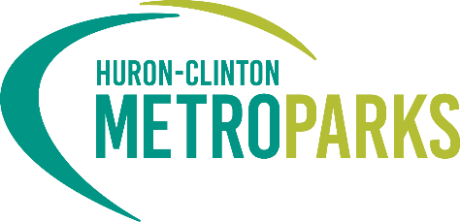
CONTACT:
Huron-Clinton Metroparks
Danielle Mauter
danielle.mauter@metroparks.com
810-494-6009

Press Release
Metroparks Receives Grant Funding to Combat the Spotted Lanternfly
Early detection is key to stopping the spread of this invasive species.

[Southeast, MI] - This spring, the Huron-Clinton Metroparks was awarded a grant from the Michigan Invasive Species Grant Program (MISGP) to survey for the spotted lanternfly (SLF) and treat the invasive host plant, tree of heaven. Spotted lanternfly is not native to North America and was first found, in 2014, in Pennsylvania. It has since expanded its range to several states in the eastern United States, with the first live population found in Michigan last year. The lanternfly has the potential to impact Michigan’s economy in a negative way. This invasive species feeds on important crops including grapes, apples, and hops, although its preferred host plant is the tree of heaven. While feeding on them, this pest secretes large amounts of a sugar-rich, sticky liquid called honeydew. Honeydew and the resulting black sooty mold can kill plants and attract other pest that disrupt crop production and harvesting.
Located within a 20-mile range of the initial Pontiac infestation, are four regional Metroparks—Kensington, Indian Springs, Stony Creek, and Wolcott Mill—situated across Oakland and Macomb counties. Combined, these parks cover over 14,000 acres and include high-quality natural areas of grasslands, woodlands, wetlands, and lakes. If left undetected, the large woodland areas with populations of tree of heaven, sumac, grape, black walnut, and maples have the potential to create a biomass center for the lanternfly in the region.
The grant funding will help the Metroparks address early detection and stop the spread of the invasive spotted lanternfly. As part of the grant project, the Metroparks will be working with a contractor on a two-pronged approach to combat the lanternfly. First, there will be a survey of the four Metroparks to check for the spotted lanternfly in all stages of its lifespan. Second, removal of the preferred host, tree of heaven, will take place.
“Receiving granting funding, like that from the Michigan Invasive Species Grant Program, is key to fighting invasive species in the Metroparks. Being proactive in our fight against invasive species will significantly decrease the effects they can have the ecosystem”, said Tyler Mitchell, chief of natural resources. “By working with partners, state, and national agencies, we can slow and eradicate the spread of harmful invasive species like the spotted lanternfly.”
According to Michigan.gov, here are some tips to identify SLF (photos can be found on their link):
- Adults are 1” long leaf hoppers. Folded wings are gray to brown with black spots.
- Open wings reveal a yellow and black abdomen and bright red hind wings with black spots transitioning to black and white bands at the edge.
- Nymphs are ¼ inch to ½ inch long, wingless, and beetle-like, first appearing black with white spots and developing red patches as they mature.
- Egg masses resemble old chewing gum, with a gray, waxy, putty-like coating.
- Hatched eggs appear as brownish, seed-like deposits.

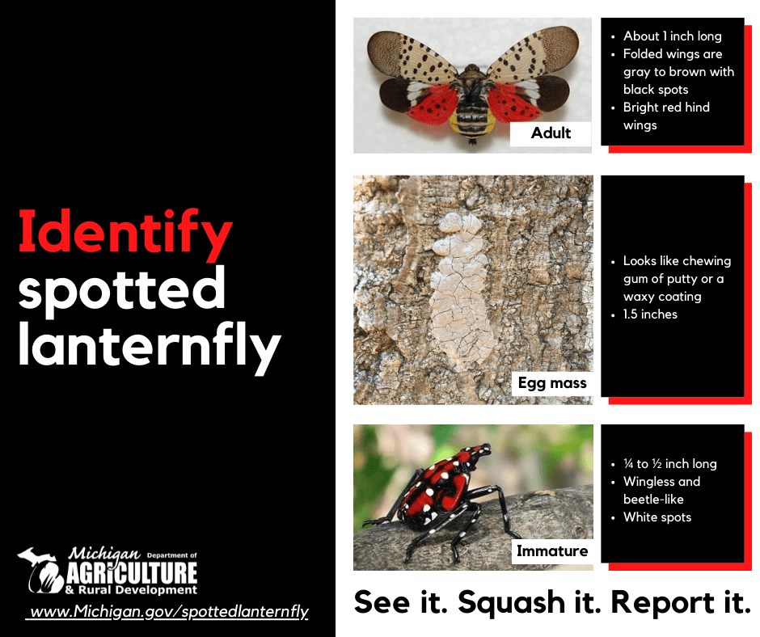
The public can help by reporting sightings of spotted lanterfly. If you identify adult or immature spotted lanternflies, take pictures, if possible, record the location, try to collect them in a container, and report your findings. If you see suspect egg masses, do not disturb them. Take photos, if possible, note the location and report it to:
- Michigan's Eyes in the Field online reporting system. Please upload photos if available to aid in identification.
- Or - use the Midwest Invasive Species Information Network (MISIN) online reporting tool.
- Or - download the MISIN smartphone app and report from your phone - MISIN.MSU.edu/tools/apps/#home
- Or – if you see a spotted lanternfly in a Metropark, use the Metroparks specific form at https://form.jotform.com/231694898764074.
Early detection and response is a common approach for new invasive species like the spotted lanternfly. The sooner these species are detected and responded to, the higher the chances are of controlling the spread of the species, or even eradicating it in some cases. Through surveying, control of preferred host trees, and engaging the public, the Metroparks can work to efficiently find any new populations in the region and quickly begin treatment.

###

About Huron-Clinton Metroparks
One of America’s premier metropolitan park systems, the Huron-Clinton Metroparks have served the people of Southeast Michigan since 1940. Managed by the Huron-Clinton Metropolitan Authority, the Metroparks are made up of 13 properties in Livingston, Macomb, Oakland, Washtenaw, and Wayne counties. Available activities include fishing, swimming, boating, hiking, nature study, biking, golf, winter sports and more. The Metroparks also provide educational resources on science, nature, history, and the environment. Learn more at Metroparks.com

