FOR IMMEDIATE RELEASE
Date: June 5, 2023

From: Jamie Kotzian, Rotary Member, Howell Melon Ice Cream Committee member

Re: Howell Melon Ice Cream

It is almost that time of year again!! As we approach the 63rd annual Howell Melon Festival this August, Howell Rotary Club will be taking pre-orders for 48 oz. Family Size portions of Howell Melon Ice Cream! Starting June 1st, you will be able to pre-order your Family Size portion on the Howell Melon Ice Cream website at https://howellmelonicecream.com/. When placing your order, you will be able to select one of several convenient pick up dates as follows:

-Thursday, August 10 5-7pm
-Saturday, August 12 9-11am
-Monday, August 14 5-7 pm

*All pick up locations are in Howell, MI

You can also follow the Howell Melon Ice Cream journey from production to delivery by visiting the Howell Rotary Club Facebook page at https://www.facebook.com/howellrotary or by visiting the official Howell Melon Ice Cream Facebook page at https://www.facebook.com/HowellMelonIceCream.

When placing your order, one 48 oz. Family Size portion of Howell Melon Ice Cream will cost you $22. This price reflects the cost of specialty production by our locally sourced friends at Guernsey Farms in Northville, MI (https://www.guernseyfarmsdairy.com). All remaining portions of the proceeds will be used to support Howell Rotary Youth programs and other Community Service projects. Some of these include Literacy Programs, Boy Scout Troop 362, Cub Scout Pack 365, Scholarships, Kids Camps, Leadership Training for Youth, Howell High School Interact Club, Exchange Student Program, Basic Human Services in our Community and so much more.

Please help us spread the word and share this news with your friends & family! It will be a great way to enjoy some delicious ice cream and support Michigan businesses all while raising funds for the Howell Rotary Youth programs!

If you have any questions about Howell Melon Ice Cream, please reach out to Jamie Kotzian at Jkotzian@wbmi.com or (989) 640-0679.

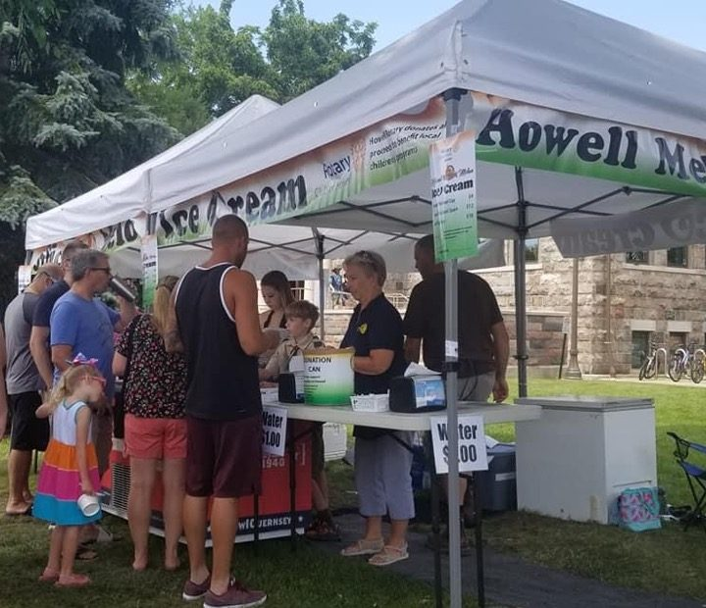

2980 Dorr Road, Brighton, Michigan 48116 · 810-494-3000 · Fax 810-494-3004 · lcuw@lcunitedway.org
2980 Dorr Road, Brighton, Michigan 48116 · 810-494-3000 · Fax 810-494-3004 · lcuw@lcunitedway.org
2980 Dorr Road, Brighton, Michigan 48116 · 810-494-3000 · Fax 810-494-3004 · lcuw@lcunitedway.org

