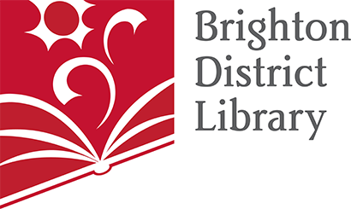

PRESS FOR RELEASE

CONTACT: Paige Greer
Marketing/PR Librarian
pgreer@brightonlibrary.info

The Spring Friends of the Brighton Library Book Sale is Here!

Brighton, MI – April 5, 2023 – What will you read next? Visit the Friends of the Brighton District Library Spring Book Sale April 25-30 to find out! Booklovers must stop by! Thousands of books, DVDs, audiobooks, and CDs will be on sale for all ages and all interests, priced from 50 cents to a dollar!

Members of the Friends of the Brighton District Library will have first access to the Book Sale on Tuesday, April 25 from 4pm-7pm. Memberships will be available at the door for those wishing to search the stacks early for first picks of the selection. The sale opens to the public Wednesday, April 26 and Thursday, April 27 from 10am-7pm; Friday, April 28 from 10am-5pm; Saturday, April 29 ($5 Bag Day) from 10am-5pm; and Sunday, April 30 (Free Day) from 1pm-3pm.

“The Book Sale selection is vast and varied, the books are in great condition, and all profits support the library through program sponsorship, equipment upgrades, and other necessary financial needs. Due to the hard work and creativity of our volunteers, Board of Directors, and generous donors, our storage unit has been filled. Thank you all. Now, everyone can come to the sale and enjoy perusing through thousands of neatly displayed, gently used books,” said Marsha Luetjen, President of the Friends of the Brighton District Library.

The Friends of the Brighton District Library is a nonprofit organization whose purpose is to actively work to further build the Brighton District Library’s funding. Funds from the nonprofit’s memberships, book sales, and special events go toward what makes the Library extra special: programming, equipment, and services for all Brighton community members. Some past and current achievements include:

- Support of the Summer Reading Program
- Livingston Reads, “One Book, One Community” events and programming
- Monthly Writers’ Workshop for teens and adults
- Books for Babies kits
- Books and material for the Special Needs Collection
- Mango Languages (online language learning database)
- Summerfest kickoff to the Summer Reading Program
- Holiday Open House
- Movie licenses (allowing the library to show films to the public)

The Spring Book Sale will take place at the Brighton District Library, 100 Library Drive, Brighton, MI 48116. For additional information about the sale or the Friends, visit https://brightonlibrary.info/fol/.

###

