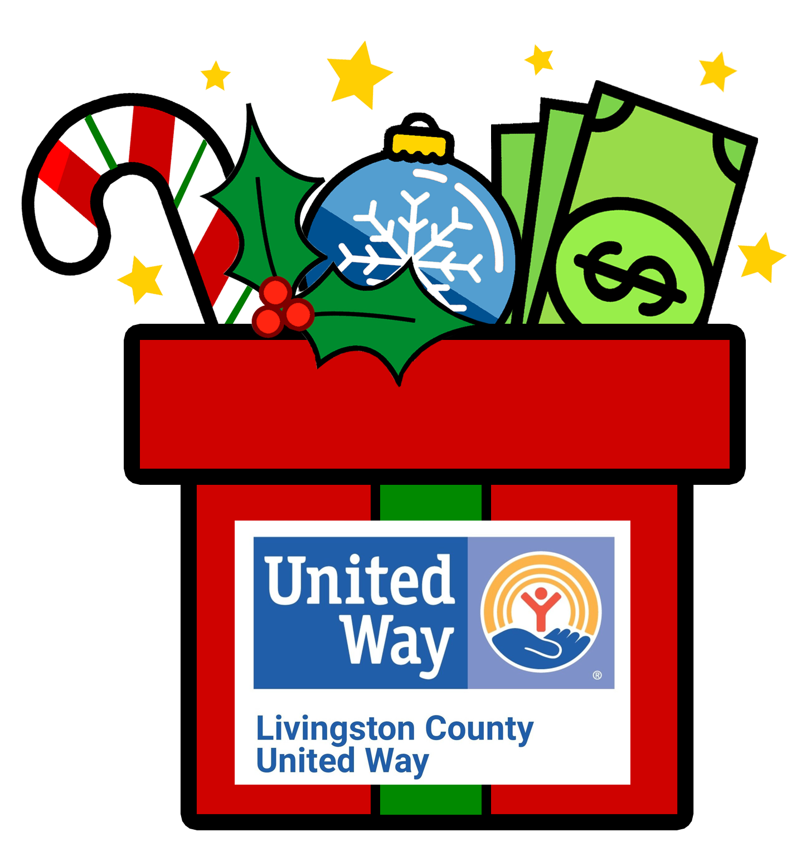

FOR IMMEDIATE RELEASE

Date: Wednesday, November 23, 2021

From: Anne Rennie, Executive Director

Re: United Way’s 15th Annual Matching Money Monday is Dec. 5

It is hard to believe that we are almost through 2022. At Livingston County United Way we are neck-deep in preparing for our community’s needs in 2023 and raising money to support those needs. This year’s Matching Money Monday event is more important than ever as many of our neighbors and friends are really feeling the impacts of inflation. We here at United Way and our 23 community funded Agencies are all seeing an increase in requests for basic needs supports, like food and rental assistance. Please consider joining us on this very special day as we work to make positive change in our hometown. All donations received on Monday, December 5, will be matched, dollar for dollar, up to total funds available! Matching Money Monday is the single largest one-day fundraiser in Livingston County!

All donations raised from Matching Money Monday go directly to help our local working families, many of whom are struggling to put food on their tables and keep their homes warm with heat and lights. This really is your Christmas Gift to the Community!

Have you ever wondered how matching work? It is from the generosity of amazing sponsors who go above and beyond to cover the match each year. Matching Money Monday 2022 is possible through these generous sponsors: Howell Rotary’s Tour de Livingston, General Motors Milford Proving Ground, Fifth Third Bank, Redi-Wall, Bob Maxey Ford, Kelli and Jim Matthew, Comerica Bank, Microworks, Brighton Ford, EctoHR, , The Musch Family, The Lafave Family, LCUW Past & Present Board Members and Anonymous Sponsors.

Please consider supporting our Livingston County Families! You can donate online at www.lcunitedway.org , by phone (810-494-3000), or drop off your donation to Livingston County United Way’s office at 2980 Dorr Rd, Brighton, MI 48116. This year we invite you to come on in the building and join us for some cookies and cocoa. You can also drive up and we will come out to you with individually wrapped cookies!

To learn more about the work of Livingston County United Way and how to get involved or donate, call 810-494-3000, visit www.lcunitedway.org or social media accounts@lcunitedway. # # #

