FOR IMMEDIATE RELEASE
Executive Committee
President
Brian Jonckheere
Vice President
Jeff Blagg
Secretary/Treasurer
Gregory Clum
Past President
Steve Williams
Community Investments Council Chairperson
Katie Pikkarainen
Publicity & Education
Chairperson
Rena M. Pomaville
Campaign Co-Chairpersons
Rick Todd
Barbara Walker

DIRECTORS
Carole Damon
Greg Hillier
Erin MacGregor
Carolyn Nelson
John O’Malley
Steve Parker
Trevor Peitz
Cynthia Penabaker
Teresa Plummer
Melissa Schwartz
Jeff Warder
Ethics officer
Darlene McManus

LEGAL COUNSEL
Athena Bacalis

EXECUTIVE DIRECTOR
Nancy A. Rosso

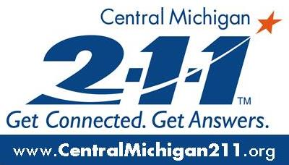

Date: September 15, 2022
Livingston County
United Way

From: Nicole Mandziuk, Development and Marketing Director

Re: Livingston County United Way is making change in your Hometown

Livingston County United Way continues to hear from families in our community that they are really feeling the impacts of inflation. Gas and food prices have taken their toll on household budgets and there does not seem to be an end in sight. In response, United Way has partnered with some of our local establishments to conduct a Round Up campaign. Beginning today and running through October 15th, local establishments throughout our county will be offering a “Make Change in Your Hometown” campaign. This means when you make a purchase the cashier will ask if you would like to donate a dollar or round up to support Livingston County United Way.
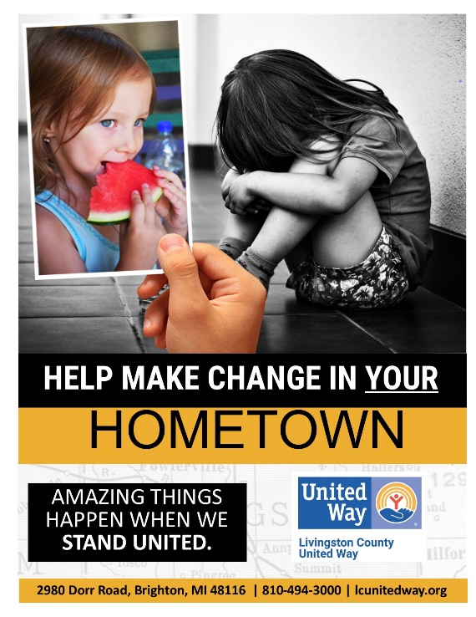

Community Partners for the Make Change in your Hometown Campaign:

Boomers Party Store in Brighton
Ore Creek Craft Cider in Pinckney
Uptown Coffee in Howell
Village Party Store in Hamburg

Stay tuned for more “Make Change in your Hometown” locations as our campaign continues throughout the year.

We need your support as we help our neighbors and our community stay strong and healthy. Amazing things happen when we stand united. If stopping by one of these wonderful community establishments in the next month is not possible, but you would like to donate, donating is easy.

- Go to www.lcunitedway.org and select the Donate button
- Mail to 2980 Dorr Road, Brighton. 48116
If you have questions or need more information, please reach out to Nicole Mandziuk at nmandziuk@lcunitedway.org
2980 Dorr Road, Brighton, Michigan 48116 · 810-494-3000 · Fax 810-494-3004 · lcuw@lcunitedway.org

