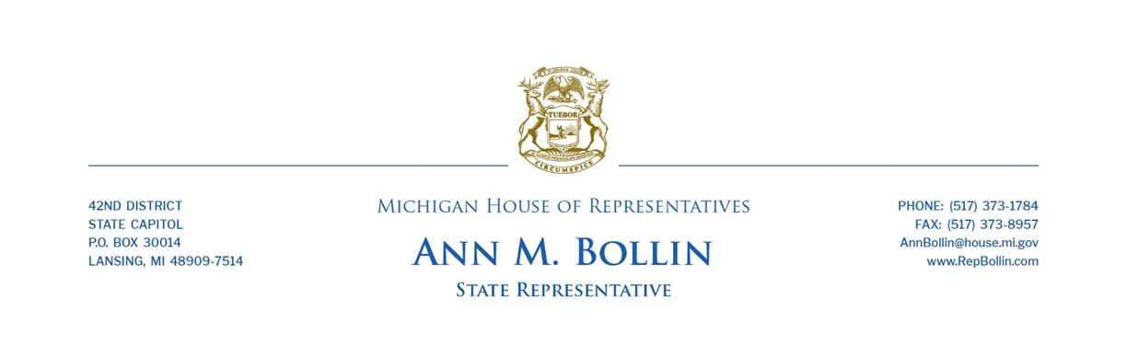
Rep. Bollin calls on MDE to release COVID-19 funds to local schools
Resources to address student learning loss should not be delayed

State Rep. Ann Bollin today called on the Michigan Department of Education (MDE) to release funding allocated by the Legislature to help Livingston County schools cope with student learning loss and other challenges created by the COVID-19 pandemic.
Bollin, of Brighton Township, said the Legislature approved a measure in June 2021 that made the distribution of federal COVID relief more equal for Michigan schools, ensuring every school gets at least $1,093 per student in additional relief funding. The MDE still has not yet provided our local schools with the application needed to apply for the funds. The delay prompted a committee hearing this week in the House.
“This funding is meant to help kids make up for lost learning and get back on track. It’s frustrating that the department has not yet made it available to our schools,” Bollin said. “Parents are worried about their kids catching up. This funding will help address the problem. It needs to be made available immediately.”
Under the plan approved by the Legislature, Livingston County school districts would be eligible for the following estimated allocations:
- Brighton Area Schools, $8,231,133
- Hartland Consolidated Schools, $5,078,566
- Howell Public Schools, $3,936,195
- Pinckney Community Schools, $1,798,360
- Fowlerville Community Schools, $1,410,870
- Charyl Stockwell Academy, $543,635
- Light of the World Academy, $122,310
- FlexTech High School, $1,683

Michigan is one of just seven states without an approved plan to distribute the third round of the federal Elementary and Secondary School Emergency Relief funding.
###

