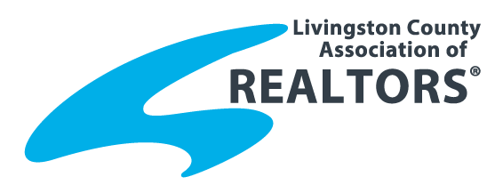PRESS RELEASE - FOR IMMEDIATE RELEASE
LOCAL ~ KNOWLEDGEABLE ~ INVOLVED ~ SINCE 1954
FROM: Livingston County Association of Realtors®
Contact: James Dewling, 2022 LCAR President
8025 Grand River Rd. Brighton, MI 48114
Office: 810-225-1100

February 11, 2022
RE: LCAR Annual Awards Announced
The Livingston County Association of Realtors®(LCAR) met on February 9 at Crystal Gardens for their General Membership meeting. Part of the meeting was the announcement of the 2021 annual awards. Lisa Bohlen, 2020 Realtor of the year, revealed the following recipients.
2021 Realtor® of the Year – Paul Harmon, Broker/Owner of Harmon Real Estate has been named the 2021 Livingston County Association of Realtors Realtor of the Year. Paul obtained his Real Estate license when he was 18 and has been a member of the LCAR since 1996. He is a third generation Realtor. Harmon Real Estate celebrated 75 years in business in 2021. Paul has served on the Board of Directors since 2015 positions including treasurer, President in 2021 and Past President currently as well as the Forms taskforce and Professional Standards Committee and is a RPAC investor. LCAR membership grew by 47 members, 6.4% during his year as President. Paul supports LCAR events including the LCAR Food Drive to benefit Gleaners, Realtor Ring Day and the Annual Golf Outing. Paul is very involved in the Fowlerville community and serves on the Fowlerville Business Association President, Fowlerville Downtown Development Authority. He was selected as Fowlerville Fair’s “Citizen of the Year”. Paul and his wife Heather have three sons, Zach, Jon and Nick. When not volunteering or selling homes, Paul can be found on the golf course or spending time with family and friends.
2021 Volunteer of the Year – Laura Toms, Associate Broker of Century 21 Affiliated has been named the 2021 Livingston County Association of Realtors® Volunteer of the Year. Laura been a member of the Livingston County Association of Realtors® since 1986 and currently serves on the LCAR Education Committee as chairwoman, Professional Standards Committee, Realcomp Board of Governors and is a RPAC Investor. Laura is a strong supporter of the Realtor® community and volunteers her time with the LCAR Food Drive to benefit Gleaners, Realtor Ring Day and Livingston Women’s Club. She has been awarded the Century 21 Quality Service award including the Pinnacle Award for consecutive years of quality service. Laura and her husband Jerry have 6 children and 15 grandchildren.
2021 Affiliate of the Year – Jamie Wasil, Cislo Title Company has been named the 2021 Livingston County Association of Realtors® Affiliate of the Year. Jamie has been in the title industry work for 17 years. She has been a member of the Livingston County Association of Realtors since 2012 serving on the Affiliates, Young Professionals Network and the Golf Outing committees. Jamie gets involved in most LCAR events including Realtor Ring Day, LCAR Food Drive to benefit Gleaners, LCAR summer picnic. Jamie always says “yes” to sponsoring, supporting, and attending both LCAR and community events. Jamie has 2 children and is very involved in their sporting activities.

#####

