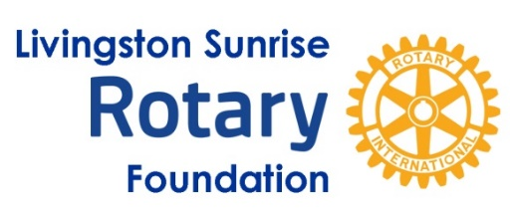
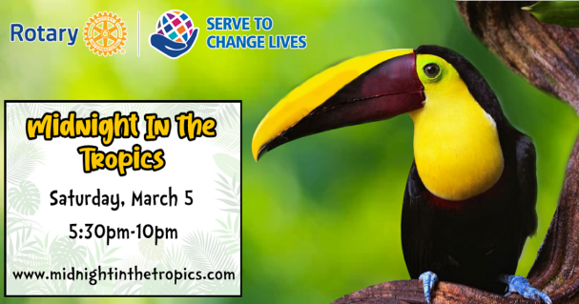

2022 Midnight in the Tropics Beneficiaries
This year Livingston Sunrise Rotary Foundation selected the Livingston County non-profit organizations listed below as our 2022 event beneficiaries. In the last seven years, through the proceeds of this annual event, we have returned over $550,000+ through our beneficiary/grant process.

These 2022 beneficiaries all serve the critical needs of at-risk youth in our Community

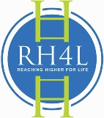
Reaching Higher
https://reachinghigherinc.org/

According to a national poll from Mott Children's Hospital, nearly three in four parents think their teen's mental health has suffered since the pandemic began. RH4Youth is needed now more than ever because too many teens today feel isolated, depressed, and hopeless. Many have lost confidence in themselves and feel powerless. So many teens have lost sight of the great potential they have and have lost the motivation to even try. Reaching Higher restores that confidence and hope through our nine-session personal leadership development program. Reaching Higher also provides both positive adult connections through our instructors and volunteer mentors and lasting peer connections through multiple class sessions where students are able to share openly and honestly with each other.

RH4Youth has helped over 10,000 young people discover the power within themselves to live their lives to the fullest. The positive and powerful impact of the program helps to change the culture of each school for the better. Students completing our program report increased self-confidence, increased motivation, better grades, feeling more connected, and overall more agency over their own lives and positive expectations for the future. We have committed partnerships with 25 schools for the 2021-22 school year with more schools committing to programs for 2022-23. Reaching Higher 4 Youth now includes school assemblies, virtual class offerings, a pilot video series, and in-person after school programs at our Leadership Lab in Brighton. This school year alone we will directly reach over 600 students.
LIVINGSTON SUNRISE ROTARY FOUNDATION is a Michigan non-profit charitable foundation.
501(c)3 MICHIGAN NON-PROFIT CHARITABLE FOUNDATION, TAX ID # 20-2455281
Please consult your tax advisor/accountant to see if this applies to you and/or your business

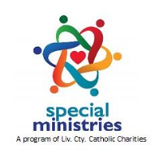
Special Ministries of Livingston Co.
www.livingstoncc.org/special-ministries-of-livingston-county/

Special Ministries of Livingston County (SMLC) is a program of Livingston County Catholic Charities (LCCC), serving adults, 18 – 80+ years, with disabilities and building a community around them so that they feel included, loved, protected and a member of the community they live in. SMLC provides participants with the opportunity to participate in an array of programs and activities in a nurturing, non-judgmental environment while decreasing barriers to engage in their community. Services are designed to empower and support each participant's access, use, and participation in the community which is crucial in order to promote activity, exploration & skill development, develop social connections, experience self-fulfillment and become more independent. We achieve this by providing an array of activities and programming based on each person’s abilities and interests. Program staff members organize indoor, outdoor and virtual activities based on participant interests, strengths and abilities. Examples of activities include adaptive archery; bowling; horseback riding; outings to local farm league baseball games, parks, farm centers, beaches; outdoor photography adventures; bible study, game nights, music in the park, softball and more.

