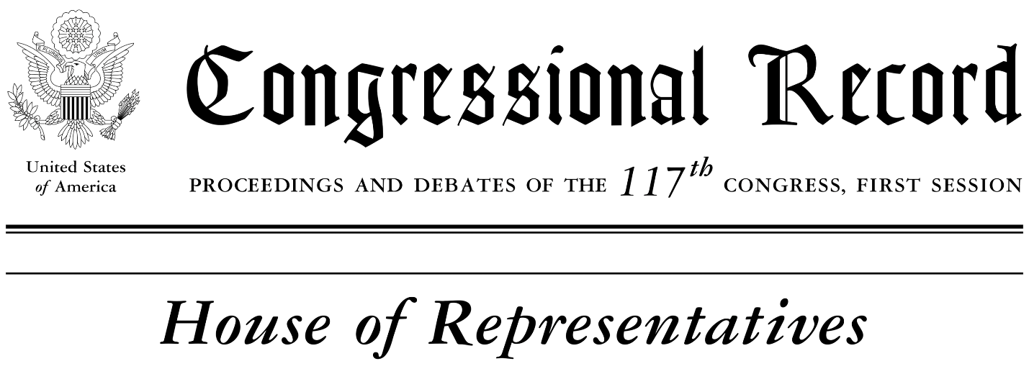

HONORING MAYOR NICK PROCTOR

HON. ELISSA SLOTKIN
OF MICHIGAN
IN THE HOUSE OF REPRESENTATIVES
November 9, 2021
Madame Speaker, I rise today to honor the retirement of a local leader and dedicated public servant who I am proud to call a friend — the outgoing Mayor of Howell, Nick Proctor.  Mayor Proctor’s ties to Howell stretch back to his ancestors when they first set down roots in the mid-19th century. First elected to the city council in 2013, he’s served as the city’s mayor for the last seven. With an agenda focused on economic vibrancy, he’s been a key partner of the Howell Downtown Development Authority and the Howell Area Chamber of Commerce in the effort to revitalize Michigan Avenue. Thanks to his vision of a combination of economic development and historic preservation, Howell was honored in 2018 with the Great American Main Street Award — a national recognition for achievements in transforming the downtown district into a cultural destination.  In this era of great challenges and uncertainty, it’s been a comfort to know that Howell has had a calm, level-headed mayor with firsthand experience in crisis management. He’s been a champion for every resident of Howell — presiding over a city council that unanimously approved the first anti-discrimination ordinance aimed at protecting LGBT and other individuals in Livingston County.  Last year, when he opted not to seek another term, he reached out via email to all of the candidates — both before and after the primary — making himself available to discuss issues confronting the  city. And while some may see his comity as a bygone  relic, Mayor Proctor would tell you that collegiality is | integral to who he is. He’s a public servant first, committed to the mission at hand.  He learned this as a former official with the Department of State’s Bureau of Diplomatic Security. In his role as a security attaché, he traveled the world, including stops in Germany, Sri Lanka, Jordan, and Japan. Later on, he served as Head of Global Security for British American Tobacco, based out of London. Needless to say, Mayor Proctor has seen the world and brought back a unique perspective to the good folks of Howell.  His ability to see things from different points of view is one of his greatest skills, and I appreciate his words as Congress has worked to pass an infrastructure bill. Last month, he was quoted as saying: “Infrastructure has no political affiliation. We need to come together to serve the people.”  It’s a message that folks in Washington would do well to heed — we were sent here to put our constituents first, just like Mayor Proctor has for the better part of a decade. I’ll miss working with him — particularly given our backgrounds in national security — but I know he’s earned a relaxing retirement filled with occasional travel, a good book, and watching the latest ice hockey or college football game.  Madame Speaker, on behalf of a grateful community, it’s my privilege to speak these words into the Congressional Record so that my colleagues in the People’s House may know that Mayor Nick Proctor made a difference.

