Citizens Protest Ruthless Plan to Kill Swans in Genoa Township, Urge Governor to Act

In Defense of Animals and Genoa Citizens Protest Planned Swan Massacre

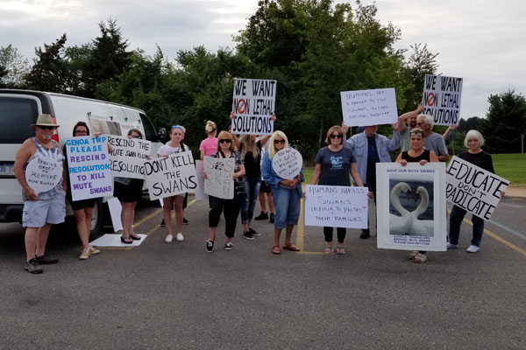
Genoa citizens protested Genoa Township’s merciless slaughter of swans on Monday. Photo: In Defense of Animals

GENOA TOWNSHIP, Mich. (August 17, 2021) — In Defense of Animals and outraged Genoa Township and Michigan residents protested the proposed ruthless massacre of swans and cygnets by the Genoa Township Board of Trustees on Monday, August 16, at the Genoa Township Municipal Office,before the Board meeting.

The Genoa Township Board of Trustees received opposition letters from nearly 9,000 In Defense of Animals supporters, which urged the township to rescind its swan killing resolution intended to free waterways for those using jet skis and other aquatic vehicles without interference from nesting mute swans.

If the current plan is followed, wildlife officials will shoot these innocent swans in the head and throw their lifeless bodies into trash bags, and finally, deposit them into landfills. Then, they will mechanically dislocate or crush the cervical vertebrae of the live baby cygnets to violently kill them.

The Genoa Township Board of Trustees authorized the killing without any input from its constituents. The board claimed it was “too burdensome” to gather the necessary 70% of the signatures of property owners to petition the Department of Natural Resources (DNR) directly.

The trustees did not address any nonlethal alternatives or consider residents who did not want to see the swans harmed, yet mute swans will be killed at taxpayer expense unless the board reverses its position.

According to a Michigan DNR official at the 2014 Swan Symposium, taxpayers are paying $125,000 a year to the U.S. Fish and Wildlife Service and $25,000 to the Michigan DNR.

“U.S federal and state wildlife officials are arbitrarily and capriciously killing Mute Swans without any scientific justification and at a tremendous expense to U.S. taxpayers,” said world-renowned conservationist and Indianapolis Prize Conservation Award Nominee Sheila Bolin, CEO of The Regal Swan® Foundation, Inc.

“These same wildlife officials woefully ignore the fact that Mute Swans are not detrimental to the environment, but rather a Sentinel species. In essence, wildlife officials are killing an early warning system that could help avert an environmental or water related catastrophe.”

On July 19, the Genoa Township Board of Trustees passed a mass-slaughter resolution for Michigan DNR to kill the mute swans on all of the lakes in the township, including:

- West Crooked Lake
- East Crooked Lake
- Lake Chemung
- Clifford Lake/Round Lake
- Zukey Lake
- Euler Lake
- Ackerman Lake
- Morse Lake
- Lime Lake
- Pardee Lake
- Brighton Lake
- Appleton Lake
- Thompson Lake
- Worden Lake
- Grand Beach Lake

​​This controversial protest received local television and news coverage. Twenty protestors pleaded with Governor Gretchen Whitmer to place a moratorium on the killings until the Michigan DNR shows the science and environmental impact study that warrants the eradication of mute swans in this state and across the U.S. They don’t want their tax dollars funding a veritable swan slaughterfest.

In Defense of Animals has submitted a request for a Zoom meeting with Gov. Whitmer, but has not yet received a response.

“What Genoa Township Board plans for these majestic birds is despicable — and it perpetuates an endless cycle of merciless killing,” said Lisa Levinson, Campaigns Director at In Defense of Animals.

“Non-lethal swan conflict resolutions are both proactive and feasible, and the people of Genoa Township would strongly prefer them over killing innocent animals if they’d been asked. Compassion and coexistence must be guiding principles for decisions related to the wellbeing of all swans, who are our wild animal neighbors.”

In Defense of Animals’ National Goose Protection Coalition helps concerned citizens to protect waterfowl in their communities via long-term, effective, nonlethal stewardship practices. The Coalition was formed in 2019 to raise awareness and stop cruel, expensive, and unnecessary lethal killing practices nationwide.

To bring local attention to this disturbing situation, In Defense of Animals and Genoa Township and Michigan residentsprotested the planned swan massacre.

Twenty members of the public attended this peaceful, socially-distanced demonstration, and others are encouraged to take action to prevent the cruel and unnecessary slaughter of mute swans in Genoa Township:

- Take action to stop the planned Genoa Township swan slaughter

Learn more and find nonlethal waterfowl stewardship strategies at: www.stopgooseabuse.org

Images: https://bit.ly/GenoaSwans

Contacts:
- In Defense of Animals, Lisa Levinson, lisa@idausa.org, 215-620-2130
- Regal Swan Foundation, Sheila Bolin, bolin.s@att.net, 407-931-6838
- Karen Stamper, helpourwaterfowl@gmail.com, 248-912-5042

In Defense of Animals is an international animal protection organization with over 250,000 supporters and a 38-year history of fighting for animals, people, and the environment through education and campaigns, as well as hands-on rescue facilities in India, South Korea, and rural Mississippi. www.idausa.org/geese

### ENDS ###

