FOR IMMEDIATE RELEASE
Executive Committee
President
Brian Jonckheere
Vice President
Jeff Blagg
Secretary/Treasurer
Gregory Clum
Past President
Steve Williams
Community Investments Council Chairperson
Katie Pikkarainen
Publicity & Education
Chairperson
Rena M. Pomaville
Campaign Co-Chairpersons
Rick Todd
Barbara Walker

DIRECTORS
Carole Damon
Greg Hillier
Erin MacGregor
Carolyn Nelson
John O’Malley
Steve Parker
Trevor Peitz
Cynthia Penabaker
Teresa Plummer
Melissa Schwartz
Jeff Warder
Ethics officer
Darlene McManus

LEGAL COUNSEL
Athena Bacalis

EXECUTIVE DIRECTOR
Nancy A. Rosso

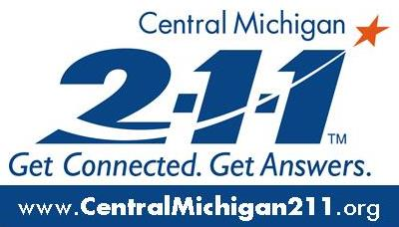

Date: August 17, 2021
Livingston County
United Way

From: Nicole Mandziuk, Development and Marketing Director

Re: Livingston County United Way 2021 Campaign is starting

Livingston County United Way is kicking off their 2021 Campaign this week. If the past year has taught us anything, it is that this community can pull together to take care of one another when times are tough. Last year, our community reacted quickly and generously to our call to lend a hand to those affected by the devastation brought on by COVID. Many of those affected in our community needed help for the first time ever in their lives. Together, we were able to mobilize funds, people and coalitions to respond immediately to our community members’ needs.

Here we are, more than a year later in this pandemic, and there are still issues affecting our county. We recognize that many of our neighbors are starting to get back to some sense of normal, but there are still many who are not back on solid ground. We would like to offer help and connection to needed resources to anyone still needing support. We also have many families saying they are on solid ground and would like to help pull their neighbors up. We can do that too. We know that once the immediate efforts end and the relief funds run out, people will still need our help to reconnect to the community and post-pandemic life.

From the recent ALICE Report, we still have 24% of our neighbors who are working, but not making ends meet. That is almost 1 in 4 and that was before the pandemic! Your donations last year supported 55 programs that helped keep our neighbors healthy, housed and safe.
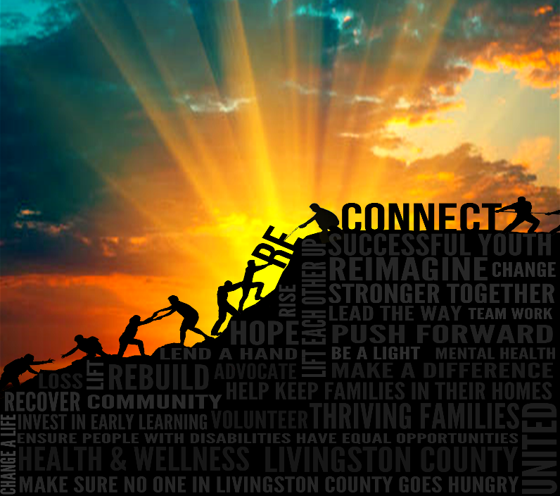
So as we embark on the 2021 Campaign, our goal is to get all of our neighbors back on their feet. If you need help, let us know. Contact Anne Rennie at arennie@lcunitedway.org
If you are already back on your feet and feel you could help others, please consider donating to the United Way Campaign. If you work outside of the county, please designate your donation back to Livingston County to make a difference where you live. Donating is easy:
- Go to www.lcunitedway.org and select the Donate button
- Mail to 2980 Dorr Road, Brighton. 48116
If you have questions or need more information, please reach out to Nicole Mandziuk at nmandziuk@lcunitedway.org
2980 Dorr Road, Brighton, Michigan 48116 · 810-494-3000 · Fax 810-494-3004 · lcuw@lcunitedway.org

