CALLING ALL ARTISTS!!
YOU ARE INVITED TO THE
2021 SOUTH LYON ART CONTEST –
“A LOGO RE-DESIGN”

(Updated 09-20-2021)
THE CITY OF SOUTH LYON WATER DEPARTMENT’S WELLHEAD PROTECTION PROGRAM IS HAPPY TO PRESENT AN INVITATION TO ARTISTS OF ALL AGES, FOR PARTICIPATION IN THE “2021 SOUTH LYON ART CONTEST - A LOGO RE-DESIGN”. THERE IS NO COST TO ENTER! THERE ARE AWARDS FOR YOUR ARTWORK!! OFFICIAL JUDGING OF ARTWORK BY MEMBERS OF THE CULTURAL ARTS COMMISSION OF SOUTH LYON, AND CITY OF SOUTH LYON WATER DEPARTMENT PROFESSIONALS!!

Guidelines, and Entry Form:

- ELIGIBILITY: Artists of any age, that live in the United States of America, may enter logo artwork into the 2021 South Lyon Art Contest.

- JUDGES:

Judge Ken Michalik, Chairman, South Lyon Cultural Arts Commission.
Judge Dayna Johnston, Commissioner, South Lyon Cultural Arts Commission.
Judge Douglas Varney, Director, City of South Lyon Water Department.
Judge Ron Beason, Chief Water Operator, City of South Lyon Water Department.

- AWARDS:

First Place Award = $200.00.
Second Place Award = $100.00.
Third Place Award = $75.00.

- ARTWORK: The logo may be black and white, or with colors. No grey tones please. The following must be incorporated into the logo: South Lyon Wellhead Protection Program

The logo artwork should have clarity, and the ability to be reproduced at a variety of scales. Artwork entries will be judged on the ability to convey the Wellhead Protection Program’s goals. The Wellhead Protection Program’s goals are to protect public water supply wells, to prevent contaminants from entering the wells, to avoid the need to clean-up contaminated ground water, and to ensure the customers of the City of South Lyon have a long-term source of clean drinking water. The Wellhead Protection Program Motto: “South Lyon Drinking Water – Safe, Reliable, and Secure”. The logo artwork will be utilized by the Wellhead Protection Education and Outreach Program. If you have any questions, please call Suzan Martin at 248-437-4942.

- MAILING, AND OTHER METHODS OF ENTERING YOUR LOGO ARTWORK: Please fill out the entry form, and send your logo artwork by United States Postal Service, FedEx, UPS or other to: Suzan Martin, “2021 South Lyon Art Contest”, 602 West Lake Street, South Lyon, MI 48178-1333, USA. Phone: 248-437-4942. Electronic submissions of .JPEG files, with at least 300 dpi, can be emailed to Suzan Martin at suzan_mccallum@hotmail.com. All logo artwork will be handled with the utmost care.

- IMPORTANT DATES:

Monday, August 9, 2021. The Art Contest Begins.
Monday, November 22, 2021. Logo Artwork Due Date.
Monday, December 20, 2021. Awards Announced.

- CONDITIONS OF ENTRY: Upon entry in the 2021 South Lyon Art Contest, each entrant verifies and warrants that they own all rights, and the entry is their sole artwork. By submitting an entry, the entrant ensures they will follow the Guidelines and have read the Conditions of Entry. The entrant agrees to indemnify and hold harmless, the City of South Lyon, and their respective affiliates, directors, employees, co-partners and volunteers. And the entrant will hold the City of South Lyon harmless from any and all claims, damages, expenses, and costs. The following are not eligible for awards: City of South Lyon affiliates, directors, employees, co-partners and volunteers of the City of South Lyon. Logo artwork entries will remain the property of the City of South Lyon Water Department-Wellhead Protection Program. For any questions, please contact Suzan Martin at 248-437-4942, or email: suzan_mccallum@hotmail.com.

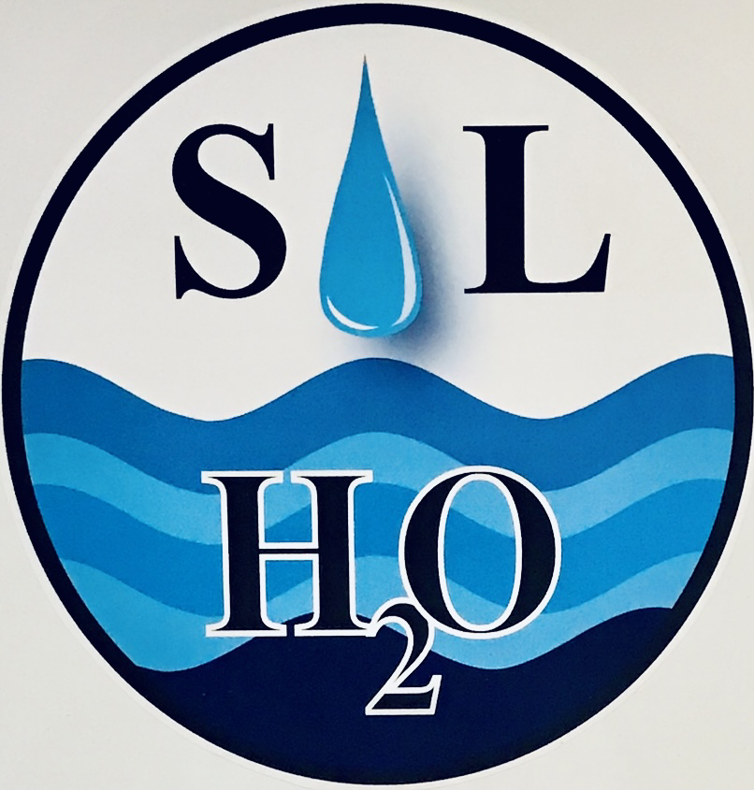
Current Logo

ENTRY FORM
2021 South Lyon Art Contest - “A Logo Re-Design”
City of South Lyon Water Department
Wellhead Protection Program
South Lyon, MI 48178 USA

Please fill out the following, and return with your logo artwork entry:
Name: ____________________________________________________________
Address: ___________________________________________________________
City, State, Zip Code: _________________________________________________
County: ______________ Phone: _______________________________________ __________________________________________________________________
E-Mail Address: ________________________________________

Please tell us what are your thoughts behind your logo artwork design? Why did you choose this design?

Thank you for your participation!! Please sign and date below, and return this form with your logo artwork entry. I have read the guidelines, and understand the conditions for the 2021 South Lyon Art Contest – A Logo Re-Design.

__________________________________ ___________________
Signature and Date

