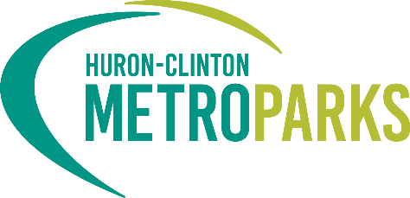
FOR IMMEDIATE RELEASE:
June 10, 2021

CONTACT:
Danielle Mauter Danielle.mauter@metroparks.com;
810-494-6009

Auditors Confirm Strong Financial Position of Huron-Clinton Metroparks
Plante Moran audit reflects both strong financial position as well as validates effectiveness of Metroparks’ fiscal management.

[Brighton, Mich.] – The results of a 2020 financial audit of the Huron-Clinton Metroparks reflects both the strong financial position and effectiveness of the Metroparks’ overall management of revenues and expenditures. This opinion was shared by Plante Moran at the June 10 meeting of the Huron-Clinton Metroparks Authority (HCMA) and validates the strength of the Metroparks’ capacity to invest in and provide safe and secure facilities and recreational opportunities.
Each year, HCMA retains an independent public accounting firm to perform an annual audit on all financial activities of the metropolitan park system that has served the people of Southeast Michigan since 1940.
Metroparks Director Amy McMillan said, “Throughout the COVID-19 pandemic the Metroparks were able to stay open, serving as a haven of respite and safe recreation. Financial diligence is a critical investment that will continue to pay dividends for residents throughout Livingston, Macomb, Oakland, Washtenaw and Wayne counties. Our commitment to being trustworthy stewards has never wavered, and we look forward to growing our park offerings in the future.”
Audit results show General Fund Revenues increased by $2.3 million (4.2 percent) while General Fund Expenditures increased by approximately $224K (up by less than 1 percent). Additionally, Metroparks’ revenue over expenditures for the year was $5.6 million even after a transfer of $4.7 million to a Capital Project Fund.

David Helisek, a Partner with Plante Moran, said, “The audited financial statements would indicate the Metroparks remain in a very solid financial position at December 31, 2020. General Fund Revenues increased approximately 2.3% over prior year while the authority was able to keep expenditures relatively flat. As a result, the Authority was able to build additional fund balance of $5.6 million. Its General Fund Balance Sheet remains strong and highly liquid with both cash and investments while funding of legacy costs are well above the threshold established by Public Act 202. Our review resulted in an unmodified opinion, the highest level of assurance an auditor can give a set of financial statements.”
Park attendance during 2020 grew to more than eight million visitors. Currently, the Metroparks are continuing to see strong demand from the public. During 2020, the Metroparks employed 449 team members and a Trust for Public Land study determined the Metroparks generate more than $90 million in economic benefits annually throughout Southeast Michigan. The past year marked the highest park operations revenue in Metroparks’ long history while golf, boat rentals and tolls also produced the highest revenues ever recorded.

The full audit report can be viewed by visiting: https://www.metroparks.com/wp-content/uploads/2021/06/Huron-Clinton-Metroparks-Authority-Annual-Comprehensive-Report-Final.pdf?x91894

###

About Huron-Clinton Metroparks
One of America’s premier metropolitan park systems, the Huron-Clinton Metroparks have served the people of Southeast Michigan since 1940. Managed by the Huron-Clinton Metropolitan Authority, the Metroparks are made up of 13 properties in Livingston, Macomb, Oakland, Washtenaw, and Wayne counties. Available activities include fishing, swimming, boating, hiking, nature study, biking, golf, winter sports and more. The Metroparks also provide educational resources on science, nature, history and the environment. Learn more at Metroparks.com.

