2021 Brighton Area Women’s History Roll of Honor Candidate Bios

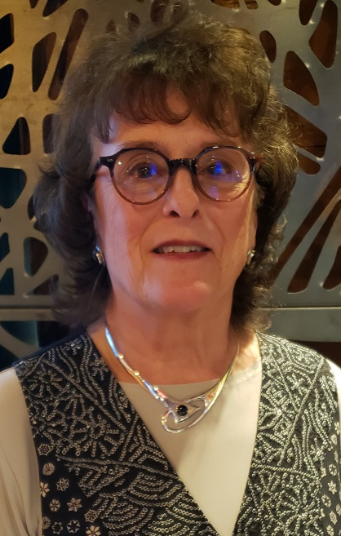

Kathleen M. Barden’s philanthropic and business acumen have touched many since moving to Brighton in 1984. In 1985, Kathleen was an original member of the Brighton Area Schools Education (BASE) Foundation and served as the second Chair of the Board. She was on the Board of Directors for Old Kent Bank/Fifth Third Bank from 1989-1997, serving on the loan, audit and personnel committees in addition to her role on Comerica Bank’s Ann Arbor Region Advisory Board. Kathleen’s 1975-2005 career as President of the Ann Arbor Credit Bureau encompassed offices in Howell, Adrian, Hillsdale, Saginaw, and Jackson. Her roles as the first female Chair of the Board for the Ann Arbor Hands-On Museum, one of the first two female members of the Ann Arbor Kiwanis Club, and Chair of the Ann Arbor Chamber of Commerce all occurred during her residency in Brighton. Kathleen was a Board Member of the Boy Scouts of America Great Sauk Trail Council, a Troop Leader of Brighton’s Boy Scout Troop 385 from 2005-2010, and led troop backpacking 50-100 mile treks as the only female (and oldest participant). From 2010-2013, Kathleen served as a Board Member for Love, Inc. facilitating connections between member churches and clients. Since 2014, she has served on the Work Skills Foundation Board, Chair in 2014, 2020, and 2021, and was instrumental in obtaining a donated building in Howell to provide services in that community. An active volunteer at St. Joseph Mercy Livingston Hospital, she served as Co-Chair of the 2017 Circus Soirée Ball that raised more than $150,000 for Emergency Services and continues her role on the Steering Committee for this health care fundraiser. In 2017, Kathleen was a weekly mentor to a female fifth-grade student via Reaching Higher, and she has served as a LACASA Board Member since 2020 working with the Building Project to expand their facilities. Kathleen is an active member of 100 Women Who Care, Cleary University’s Helen’s Circle, and served as Treasurer from 2010-2017 of the Trapper’s Cove Homeowners’ Association. Kathleen holds a Bachelor’s degree from Michigan State University.

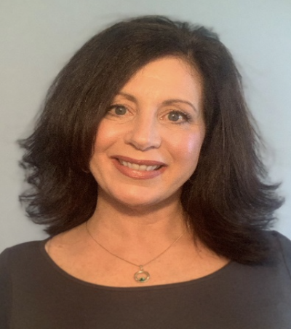

Therese K. Cremonte, P.E.M. has been the Livingston County Emergency Manager since 2016, the first woman to hold this position, and was honored in 2018 as the Michigan Professional Emergency Manager of the Year. Since 2015, Therese has been Chair of the Regional One Homeland Security Planning Board and is the current President of the Michigan Emergency Management Association (MEMA). As Director, her department is focused on the safety of citizens through information, planning, and preparation for all emergency events and potential hazards. During her tenure, she has overseen response to the December, 2016, 53-car accident that closed I-96 for more than 12 hours and the March, 2017, week-long power outage of the entire County, orchestrating shelter and access to public safety needs. Therese implemented the first public alert system for the County and has coordinated activation of the Emergency Operation Center and distribution of Personal Protective Equipment to necessary personnel during the COVID-19 pandemic. A Michigan State Police (MSP) trooper from 198-2016, Therese rose to the rank of Lieutenant, and retired from the MSP as Assistant Post Commander of the Lansing Post: their first female command officer. As the first person in her family to attend and obtain a college degree, Therese holds a Bachelor’s of Science degree from Ferris State University and is a graduate of the Michigan State University’s School of Staff and Command program. She taught D.A.R.E. in Livingston County Schools for two years, instructs Incident Command System training for local response agencies, and presents to local groups on safety, preparedness, and Emergency Management.

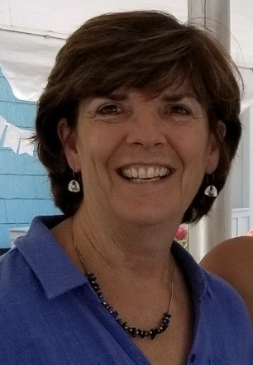

Ellen Lafferty and her family have lived in Brighton since 1981 and was employed as a special education teacher for Brighton Area School’s (BAS) Maltby Middle/Intermediate School from 2000-2014. Active in the Brighton Education Association (BEA), Ellen was a long-term representative on the bargaining team and two term President from 2010-2014. Her leadership was key to crafting fair, open, and equitable decisions as BAS faced deep statewide funding cuts and subsequent staff layoffs. As a leader for the Girl Scouts of America, Ellen established the first Girl Scout Troop at St. Patrick’s School in 1988. Since 2018, Ellen has actively participated in the creation of and chairing the League of Women Voters of Ann Arbor, Brighton/Howell Unit while making the organization a vital presence in Livingston County. Current activities of the League that Ellen has led include registration of local students to become engaged voters, hosting public candidate/informational forums, publishing online/printed voter guides listing candidates’ views on vital issues, and working with the Livingston County Complete Count Committee to emphasize the importance of completing the 2020 Census. Ellen fosters the non-partisan focus of the League of Woman Voters and encourages member participation and investment for ongoing viability. Ellen earned a Bachelors in Special Education/Elementary Science from Eastern Michigan University and a Masters in Learning Disabilities from Madonna University. She currently volunteers at the music venue The Ark in Ann Arbor.

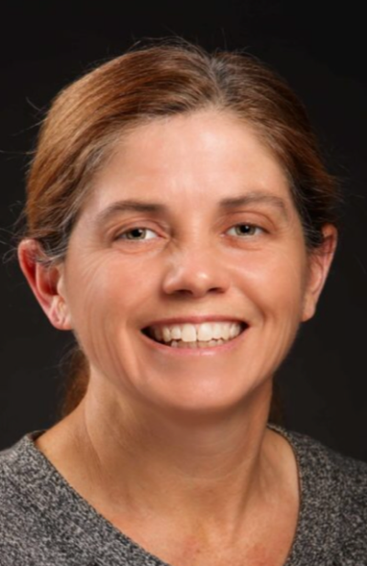

Colleen Tokai Monroe is a 1982 Brighton High School graduate and an accomplished author who represents Brighton on a global stage. Her 2000 first book “A Wish To Be A Christmas Tree” became an instant holiday classic that was read Christmas morning by the Today Show’s Katie Couric on national TV and garnered attention by President George W. Bush and First Lady Laura Bush. Colleen has authored six additional books with her illustrator husband. Since 2007, Colleen has worked in Special Education for Brighton Area Schools (BAS), helped with the seventh grade transition program at Scranton Middle School, and served as volunteer photographer for several BAS sports teams. Colleen was honored as a Coaching Legend in 2019 for her multi-year service as Head Coach of Scranton Middle School’s Girls Cross Country and Track and Field teams. She is the Howell Farmers Market manager and finds ways to volunteer and give back to the community including several years helping out with Bingo at a local retirement home. Providing inspiration to students through her books and actions, Colleen demonstrates how commitment, dedication and a strong work ethic can make a difference within our community.

Rhonda R. Trask has served as Co-Pastor and Church Ministries Director of Brighton Assembly of God Church since 2009 after previously being the Youth Pastor. In 2013, Rhonda founded Heart’s CRI Ministries and directs over 200 volunteers to support foster children and foster/adoptive families. In 2017, Rhonda was appointed Chair of the Michigan Department of Health & Human Services Community and Faith-based Coalition overseeing wraparound services and supports 13,000 Michigan children in foster care and over 11,000 churches seeking to create community business partnerships within Michigan. Monthly events for state agencies coordinated by Rhonda include adoption-approved families meeting with foster children for potential adoption, and Rhonda has hosted workshops on Human Trafficking in churches and organizations fighting human trafficking throughout the state. Rhonda earned a Bachelor of Arts degree in Telecommunications from Michigan State University, a Madonna University Teaching Certificate in History and English, and a Master’s in Education degree from Wayne State University. Prior to her position at Brighton Assembly of God Church, Rhonda was a middle school teacher for Farmington Public Schools.

