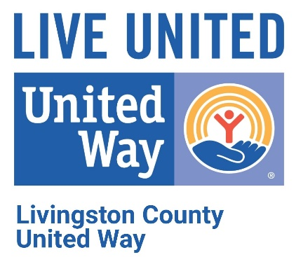

FOR IMMEDIATE RELEASE

Date: Tuesday, January 5, 2021

From: Anne Rennie, Executive Director
Re: Livingston County United Way’s 21 Day Equity Challenge

Over the summer, United Way Worldwide Diversity, Equity & Inclusion Team created a 21 Day Equity Challenge and engaged many of the local United Ways in participating. Over 1,000 people answered that call and now we are able to share this incredible learning model with all of you!

We will host the challenge, starting January 18th and ending February 8th, via e-newsletters sent every day to those who sign up to participate. In the newsletters we will post a series of articles, videos, and podcasts about equity for 21 consecutive days. Each challenge will be designed to develop your personal equity lens and will take you no more than 15 minutes a day (unless you choose to do more!). Additionally, we want this challenge to be part of a larger conversation. To cultivate this, we will dedicate specific days throughout the challenge for reflection and community conversations through video chats.
Why Should You Do This?
There is some confusion on what is Equity vs. Equality and why is it important. Equality is giving everyone the same thing. Equity is giving everyone what they need to have the same experience. By looking at equity, we can become more aware of how people are marginalized and what we can do to help reduce forms of oppression.
Now, we'll be the first to admit that you may be thinking, "A 21 day challenge? That's quite a long time. I'm not sure that I can do this for 21 days…" and to this we'll say that your concern is valid. 21 days is a long time. However, we want you to know that we took this into account when designing this challenge, and we will be distributing learning materials in a manner that we feel won't be overly obtrusive to your day.
For starters, each day’s content only requires 10-15 minutes of your time. The newsletters have a substantial amount of content to provide a variety of learning opportunities dependent on your background and experience. We are hopeful that you will find content that is interesting to you, and will keep you intrigued and engaged for all 21 days.
Additionally, we've also taken into consideration different learning methods. For some, we recognize that you may learn best by reading. For others, you may learn better by listening. And lastly, you may learn best by watching videos. We've included all three. This allows you a plethora of options for how you'd like to complete the challenge each day.

Sign Up
Please register at the link below by January 15th.
http://events.constantcontact.com/register/event?llr=tphqs6bab&oeidk=a07ehfqi85915d3b600

Additional Information
Originally created by Debby Irving and Dr. Eddie Moore, Jr., our friends at the Interaction Institute for Social Change introduced us to the challenge. Our unique UWW challenge was crafted by the Diversity, Equity & Inclusion intern Julian Brown with support from Geniro Dingle.

Feel free to contact Anne Rennie at arennie@lcunitedway.org or 810-494-3000, if you have any questions.
To learn more about the work of Livingston County United Way and how to get involved or donate, call 810-494-3000, visit www.lcunitedway.org or social media accounts @lcunitedway.
# # #

