2020 Brighton Area Women’s History Roll of Honor

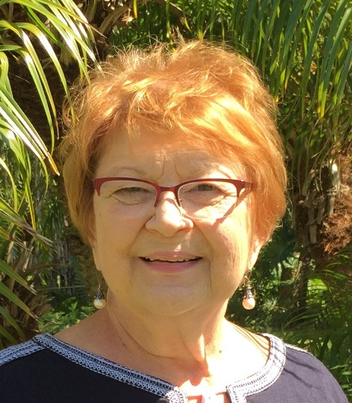
Carolina Louise DeLuca was born in Mellus Hospital, graduated from BHS in 1958, from Marygrove College with a Bachelor’s degree in Speech/Drama/Theatre and English, and completed a 1967 Master’s degree in Oral Interpretation from The University of Michigan. Her family owned DeLuca’s Sweet Shop at 128 W. Main Street. Carolina chaired the 1967 Bicentennial Spectacular Committee for the re-enactment of City of Brighton History. After beginning as a 1963 sixth-grade teacher at Miller Elementary School, Carolina became an English and Drama teacher in Lapeer, Michigan. Her 30-year teaching career included 7-years as English Department Chair and 14-years as Lapeer Education Association Treasurer, as well as directing numerous plays, productions, and musicals. Carolina has been a board member of the Brighton Historical Society since 1995 and organized a successful spaghetti dinner fundraiser. From 1996-2003, Carolina worked with the Women’s Resource Center and chaired the Child Abuse Prevention (CAP) Council, developed several abuse prevention programs, including Chester’s Solutions, the Annual Children’s Fair, the Annual Fundraiser, and the Annual Conference regarding child abuse prevention. For many years, Carolina authored a monthly article on child abuse prevention issues for the Livingston County Press. Honored for her work with Livingston County youth, Carolina earned the Champion for Children Award during the 1990s. From 2003-2013, Carolina was active in fundraising efforts for The Connection Youth Services (TCYS) to provide emergency housing, counseling, and teaching independent living skills to homeless youth. Carolina is a founding member of Livingston County 100 Women Who Care and continues to introduce others to the joys of theater and community service.

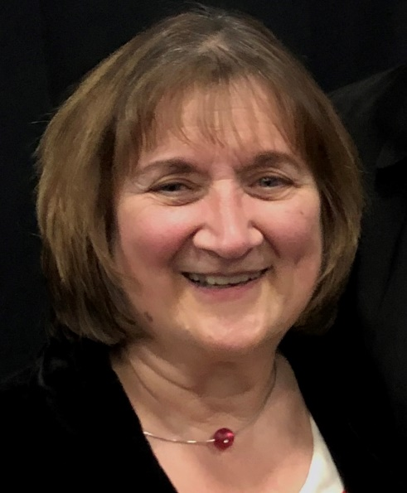
Josephine DeLuca DelVero was born in Mellus Hospital, graduated from BHS in 1960, and earned both Bachelor’s and Master’s degrees from The University of Michigan. Hired in 1968 as a Hartland Schools high school counselor, Jo’s 40+ year career in the district included initiating the 1984 Legacy Alternative Education program that has grown into a full high-school for students who do not flourish in a traditional setting. The Jo DelVero Award is presented each June to a graduating senior demonstrating success in the face of adversity. Jo began the Student Assistance Program (SAP) for students suffering life issues through support groups, prevention, and training. Jo was appointed and served on the Livingston County Mental Health Board from 1984-1994, and as a founder in the early 1990s of the Livingston Child Abuse and Neglect Network, her work on the by-laws committee led to the present day Child Abuse Prevention (CAP) Council. Jo is a past recipient of the Champion for Children Award. A founding member of the Livingston County Community Alliance (LCA), Jo also spearheaded the local Hartland Community Alliance. Jo has been an advocate for The Connection Youth Services (TCYS) teen shelter since its inception and was chair of their Annual Fundraiser for ten years. Jo is a founding member of Livingston County 100 Women Who Care and continues to advocate support and resources for community members at-risk and in need.

Melinda Rodabaugh Kinsey has been a leader with the Brighton Area Historical Society since 2002, serving on the Board of Directors, Treasurer from 2002-2013, and currently is recording secretary, archiving documents/events on a weekly basis to preserve the history. At the 2017 City of Brighton 150th year celebration, Mindy planned, organized and oversaw creation of 14 period outfits, historical displays, and events. Since 2008, she has been President, Treasurer, Secretary of the Friends of the Brighton District Library (FBDL) Board of Directors, while organizing tsemi-annual sales of over 18,000 books. Mindy served as President, and Co-Program Director of Casual Quilters of Brighton since 2009 while creating Quilts of Valor for service members and veterans since 2010. Mindy has served as an Election clerk for Brighton Township since 2017 and participates as Secretary and Scrapbook Chair of the Pleasant Valley Social Club, a 91-year-old tradition of Brighton Township.

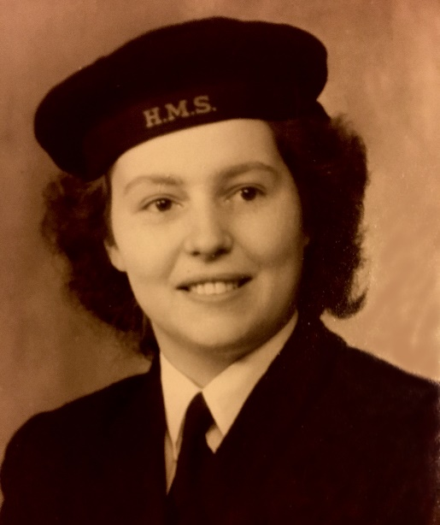
Marie Sedmak served in the British Royal Navy (1942-1945) during the height of World War II, joining the Women’s Royal Navy Service (WRNS), spent six weeks in Scotland for Basic Training before assignment to Chatham-Kent Naval Base. A transfer to Rochester, England, saw numerous German buzz bombs flying over en route to London targets, before posting to the Signals Distributing Office in tunnels under Dover Castle created during the 1800s. Marie and her US Army Air Corps husband moved to the United States in 1946 and joined the Brighton community in 1971. A member of the Brighton Garden Club since 1990 and recognized with the Club Appreciation Award and the State Life Membership for meritorious service.

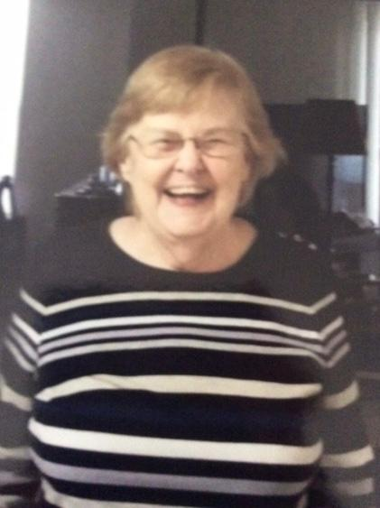
Susanne Roys Seitters served in the United States Navy (1953-1956) and completed training in 1954 as an Aviation Electronics Technician during the Korean War. Susanne worked in the Davison, MI, Post Office for twenty years, served as a Sunday school teacher, and tutored adults learning to read. Susanne’s needlework skills supported her quilter’s group projects of creating lap-sized quilts for veterans in wheelchairs. Susanne serves as a volunteer mentor to new residents at Independence Village in Brighton.

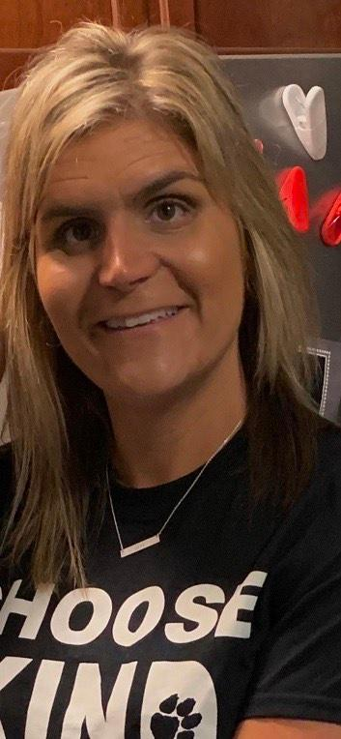

Karen Storey, a 1995 BHS and 2000 Eastern Michigan University graduate, began her teaching career at Maltby Intermediate School working with students with emotional impairment. In 2008, Karen began the Brighton Pack of Dogs Program to have social-emotional therapy dogs interact with students. Community funded and supported (including veterinary care, grooming, and dog food), Brighton Area Schools in 2019 became the first Michigan district to own a therapy dog at every school, and. Karen has led all aspects of this program throughout its development. Karen is also a 2016 co-founder of the non-profit organization “I Will Right Now” assisting families of Brighton Schools that are struggling financially because of catastrophe or life-altering illness.

Athletic Championship Honoree:

Evelyn Money won the Michigan Scholastic Cycling Association (MISCA) and was crowned the first female Varsity State Champion at the state mountain bike championship.

