2019 Brighton Area Women’s History Roll of Honor

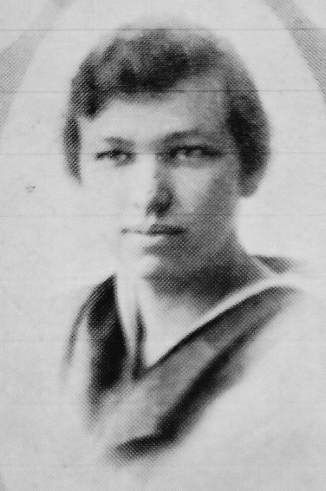
Haidee F. Judson Brady (1893-1983) was the second woman to vote on March 10, 1919, in the Village of Brighton’s vote for Village Council members held after women were first allowed to vote in Michigan on March 10, 1919. Along with Charlotte Mellus, she was an election inspector and clerk hired at a rate of $3/day (same as the men) to assist the other women (250 were registered) with the voting process held at the Village Town Hall at 202 Main Street. Haidee was a 1910 graduate of Brighton High School and a 1917 graduate from Michigan Agricultural College (MAC). She was a member of the first women’s MAC tennis team and her contributions were recognized with a varsity letter from Michigan State University in 2002. Haidee taught in the Brighton School District prior to and after graduation from college in 1917 and provided marketing support to her husband’s business based in the Village of Brighton. Haidee was a confirmed believer of education for everyone and remained in Brighton raising five children (4 female, 1 male), all of whom pursued education beyond high school. Haidee was an active volunteer and strong supporter of Village of Brighton achievements and celebrations.

Charlotte L. Haight Mellus (1889-1925) was the first woman to vote in the March 10, 1919, election for Brighton Village Council candidates. Along with Haidee Judson, she was an election inspector and clerk hired at a rate of $3/day (same as the men) to assist women voters coming to the second floor of Town Hall (202 Main Street). Records show that 250 women registered to vote in that election. Charlotte moved from her home in Cass City to Pontiac to work at the Eastern Michigan Asylum where she obtained her nursing certification in December, 1912. She helped her husband establish his medical practice in Brighton and served the community and church in many capacities, including the Rebekah Lodge treasurer and chaperone at many high school programs. In 1921 with Mrs. Harvey Jacobs, Charlotte operated a summer camp for up to 59 girls at Silver Lake. Charlotte nursed and cared for her husband, Dr. Horace Mellus, when he contracted typhoid fever in the autumn of 1924. In February, 1925, Charlotte contracted typhoid fever and was hospitalized until she died on March 3, 1925.

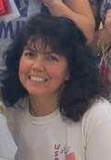
Reneé R. Nix has led advocacy for student health/fitness through jump rope activities since 1998 when she coordinated Lindbom Elementary’s American Heart Association Jump Rope for Heart event. The Jumpin’ All-Stars Jump Rope Team was established in 2007 to showcase competitive jump rope in local, regional, national and international venues. In 2018, the Brighton-based team placed fourth in the national USA Jump Rope (USAJR) competition, and earned first place at the International Jump Rope Competition in 2012. In 2013, the team placed fifth at the NYC Apollo Theatre with the National Double-Dutch League. The nationally competitive non-profit performance and competition team from Livingston County has performed in the NYC Macy’s Thanksgiving Day Parades, television commercials, film, and local festivals/events. Reneé became a nationally-certified USAJR judge and coach in 2002, a camp director of USAJR events since 2015, and conducts annual international jump rope workshops. Founder of Teaching, Unity, and Reaching Nations (TURN) in 2010, this group of 16 jumpers each year trains future leaders and builds understanding of different cultures through exhibitions and education in Israel (2010 & 2015), Brazil (2012-2016), eight locations at World Cup Soccer stadium matches, the 2016 Rio De Janeiro Olympic Games, and five trips to Europe. A substitute teacher for K-12 students since 2001, Reneé has been active leading the Lindbom and Hornung Elementary Jump Rope Clubs, encouraging her students to share skills with Hartland Community Education, and hosting over 35 international exchange students in her home. An ordained minister since 2014, Reneé is a trained missionary.

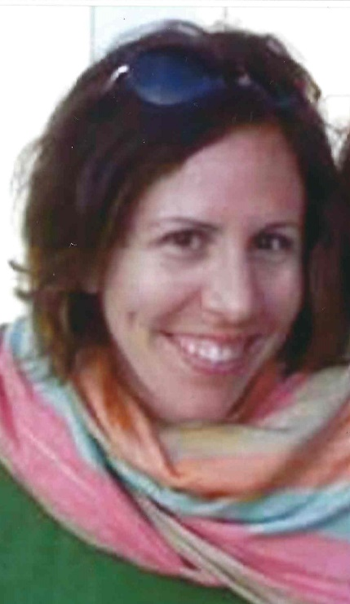
Sarah Richardson-Burns, PhD (1976-2018) was a 1994 BHS graduate who earned a BS in Biology from the University of Michigan in 1998, and a PhD in Neuroscience at the University of Colorado in 2003. Co-founder of Biotectix, an Ann Arbor based company and laboratory, in 2007 that created a patented conductive polymer coating for clinical biomedical devices that improved the interface between electrodes and human tissue. In 2017, the laboratory and company were purchased by Heraeus Medical Components, and the pioneering products developed by Sarah and her team are still being used today on electrodes used in retinal and cochlear prostheses, deep brain stimulation, spinal cord stimulation, peripheral nerve stimulation, cardiac rhythm management, and electrophysiology and biosensors. In 2016, after a 2013 diagnosis of metastatic colon cancer, Sarah founded Align Botanica to develop products that used the purest ingredients based upon ancient healing knowledge and medical evidence-based information. These products were in the testing phase when Sarah passed, and her sisters continue to develop products using mindfulness and nature’s medicines. In 2017, Sarah became a certified yoga teacher to mentor and guide other cancer survivors.

Nina Jones Cord Stowe (1876-1967) was the first woman elected to the Brighton School Board on July 14, 1913, at which seven voters in attendance at the meeting were women. Nina became a rural teacher in 1926 and taught at the Foster School on Gregory Road in Iosco Township until 1929. Although the women’s suffrage ballot issue failed in Michigan in 1912, the Brighton High School homecoming parade that year hosted a rig representing women’s Suffrage, the high school debate team tackled the question, and at a class election the students voted ten to one in favor of voting rights for women. Women’s suffrage was in the mind of Brighton residents, and Nina Cord’s willingness to serve on the school board provided significant leadership as women sought representation in elected bodies.

Mary Zizka St. Pierre, RN graduated from Brighton High School in 1968 and was a trauma RN at Sinai-Grace Hospital in Detroit and was an accredited CCRN and preceptor for nurses. Mary taught Advanced Cardiac Life Support (ACLS) to both nurses and doctors from 1995-2015. She developed and implemented a “clothing closet” for indigent trauma patients that needed replacement clothing at the time of hospital discharge from 2010-2015. Mary became one of the first female radio announcers working in Traverse City, Lansing and Detroit at WOMC as Midnight Mary until leaving radio in 1989 to earn her nursing degree. Mary has volunteered at Gleaners Food Bank since 2015, working 9-12 hours per week. A member of the Livingston Sunrise Rotary Club since 2014, she has served on their Board of Directors for Community Service and co-chair of the “Midnight in the Tropics” fundraiser. Mary also volunteers yearly with the United Way’s Community Connect, delivers Christmas packages for Livingston County Catholic Charities, and is a member of the Livingston County Nurse Reserve Corps helping to teach CPR classes and immunization clinics. Mary has served in medical clinics on mission trips to Haiti in 2010 and in Mexico in 2015, 2016, & 2017.

Athletic Championship Honorees:

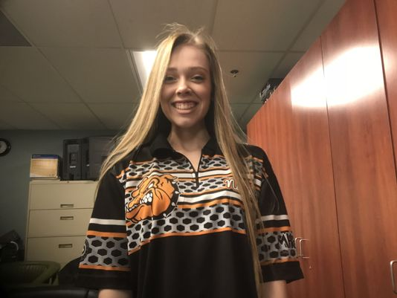
Natalie Klein was selected 2018 Miss Bowling by the Michigan High School Interscholastic Bowling Coaches Association. All four years Natalie qualified in the top eight of a six-game block. During state match play, she finished seventh and eighth her first two years, second her junior year, and third her senior year, leading all girls and boys in the 2018 state final six-game qualifier block. Natalie averaged 209 in KLAA competitions, over 20 pins higher than second place.

