O

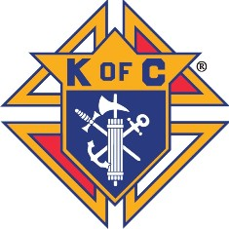HELPING RYAN”

Remember the movie Saving Private Ryan? Well, the Knight of Columbus, Archbishop Fulton J. Sheen Council #7444 of Milford and the councils of District 8 are having a benefit dinner called “Helping Ryan”. We would like to help Ryan Wismer go to college to follow his dream to become a schoolteacher. Things were going great for Ryan. He just finished his eleventh grade year, was looking forward to summer and his last year at Lakeland High School. He had his mind set on going to college after his senior year.

It was June 13, 2017, just days after school was out when his mom and dad Victoria and Randy went to get their car from a dealership on Grand River. Randy took his motorcycle. Randy and Vickie were struck from behind by another vehicle. The tragic accident resulted in the death of Vickie and Randy being in a coma quite some time. Randy and Vickie both worked at Milford pharmacy.

Pretty rough on a seventeen year old young man.

The Knights will host a benefit dinner on June 16th, 2018 at St. Mary’s hall, 1955 E. Commerce Road, Milford, MI. The event will start at 6:30 p.m. There will be a dinner consisting of salad, roast beef, roast pork, baked and mashed potatoes, green beans and dessert.

Tickets are thirty dollars a person. For setting up and ordering food, we must have reservations by June 11th. We will have a 50/50 drawing and if any merchant would like to donate a gift we thank you now and and at the dinner. If you can’t make the dinner but would like to donate to Ryan’s cause please send your check to John Rogers, 3101 Sands Ct., Milford, MI 48380. Make checks payable to Knights of Columbus #7444. Earmark them Ryan’s Dream.

For tickets, call John Rogers at 248-714-5353.