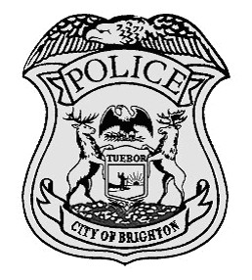
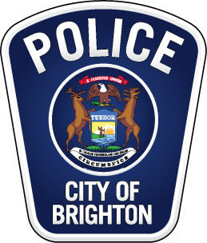
Brighton City Police Department
440 S Third St Brighton, MI 48116 810-227-2700

PRESS RELEASE
For Immediate Release
January 29, 2018
The Brighton Police Department is currently investigating a potential fraudulent GoFundMe account called Candace Kicks Cancer. While the investigation is still ongoing, there is enough information from independent sources that strongly suggest the account was fraudulently used to accept donations based on the suspect’s claim to have stage four breast cancer. GoFundMe records show 399 people donated money totaling $31,645 since April 15, 2017. The investigation is still ongoing; however, we expect to submit charges to the Livingston County Prosecutor’s Office in the near future. GoFundMe has closed the account and is working hand in hand with the Brighton Police Department to refund all the donors.
GoFundMe statement:
"Our platform is backed by the GoFundMe Guarantee, which means that in the rare case that GoFundMe, law enforcement or a user finds donations are misused, donors are fully protected and will get their money back. Additionally, it’s important to remember that misuse is extremely rare on our platform. Campaigns with misuse make up less than one-tenth of one percent of all campaigns. With that said, there are unfortunate and rare instances where people create campaigns with the intention to take advantage of others’ generosity. In the small handful of cases where misuse occurs, GoFundMe takes action to resolve the issue. In this case, the user has been banned, and we are working with law enforcement officials to ensure donors are refunded.
For additional information on our measures to protect the platform, please visit www.gofundme.com/safety. If you donated to a GoFundMe campaign to support Candance Streng, please contact our team by clicking here - www.gofundme.com/guarantee." -GoFundMe
If the media has additional questions, please contact press@gofundme.com.

Chief Robert Bradford

