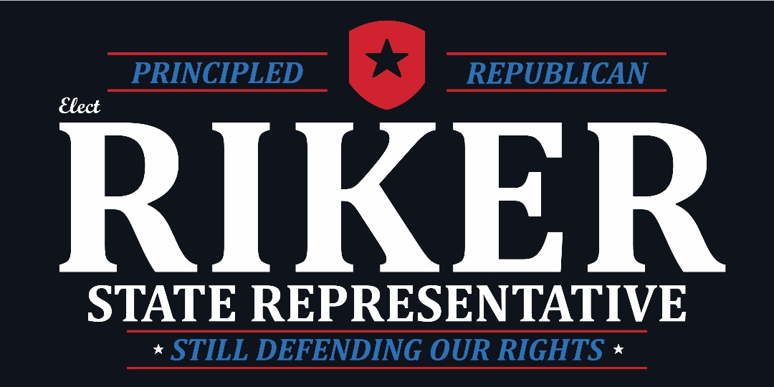

FOR IMMEDIATE RELEASE
Contact: Joe Riker, (734) 740-2873

JOE RIKER ANNOUNCES CANDIDACY FOR STATE REPRESENTATIVE IN THE 42ND DISTRICT

Brighton, Michigan – Saturday, January 20, 2018 – Joe Riker from Brighton Township announced his candidacy for the 42nd state representative seat being vacated by State Representative Lana Theis.

“I am excited and honored to announce my candidacy for state representative. After serving 9 years in the United State military, I have first-hand experience as to what service and sacrifice mean,” said Joe Riker. “When State Representative Lana Theis choose to run for the state senate, I knew in that moment it was fate. I want the honor of fighting for the people I call my friends, family and neighbors as our state representative in Lansing.”

From 2004 until 2007, Joe served in the United States Army as an infantryman, serving in the 3rd Brigade 2nd Infantry Division 2/3 Stryker Battalion. During his service in the Army, Joe was deployed to Iraq where he served in a 15 month combat deployment. Following his service in the United States Army, Joe then joined the United States Navy. During his service from 2008 until 2013 he served as an equipment operator in the Seabees 133 Construction Battalion and was deployed to Kandahar, Afghanistan and Okinawa, Japan.
Joe, along with his wife Leah and their two children moved back to Michigan in 2013, where he earned his bachelor’s degree from Eastern Michigan University with a major in psychology and a minor in social work. Upon graduation, he was hired by U.S. Congressman Mike Bishop to be a veteran case worker/outreach. Most recently, he was given the added role as the community liaison to Livingston County for the Congressman.

Joe has dedicated his time in Livingston County to improving the lives of his fellow residents. He serves as a member of the Livingston County Veterans Affairs Committee, a member of the Livingston County Health and Human Services Board and as a member of the Board of Directors for the Brighton Veterans Memorial. He is also an active member of the Brighton VFW, the Brighton American Legion, the Livingston DAV and Livingston County Veterans Council.

“I believe the focus of our state government should be freedom, family and fundamentals! Even with the work that has been done over the years, there are many important issues facing the residents of Livingston County such as tax reforms, auto insurance reforms and health care reforms. In addition, the issues being discussed at the federal level, such as taxes and health care, will have a direct effect on the families in Livingston County and the decisions that are made in Lansing.”

“I am lucky enough to be in a position where I can devote my time and energy to serving my community. I want to be their voice in Lansing where I can continue to defend our rights. I want to keep our community strong; and as your State Representative I will continue to carry on the tradition of fighting for pro-life, pro-family and pro-second Amendment values that the residents of Livingston County cherish.”
For more information on Joe Riker, visit www.JoeRiker.com.

Photo cutline: Joe Riker with his wife, Leah, and their two children.

####

